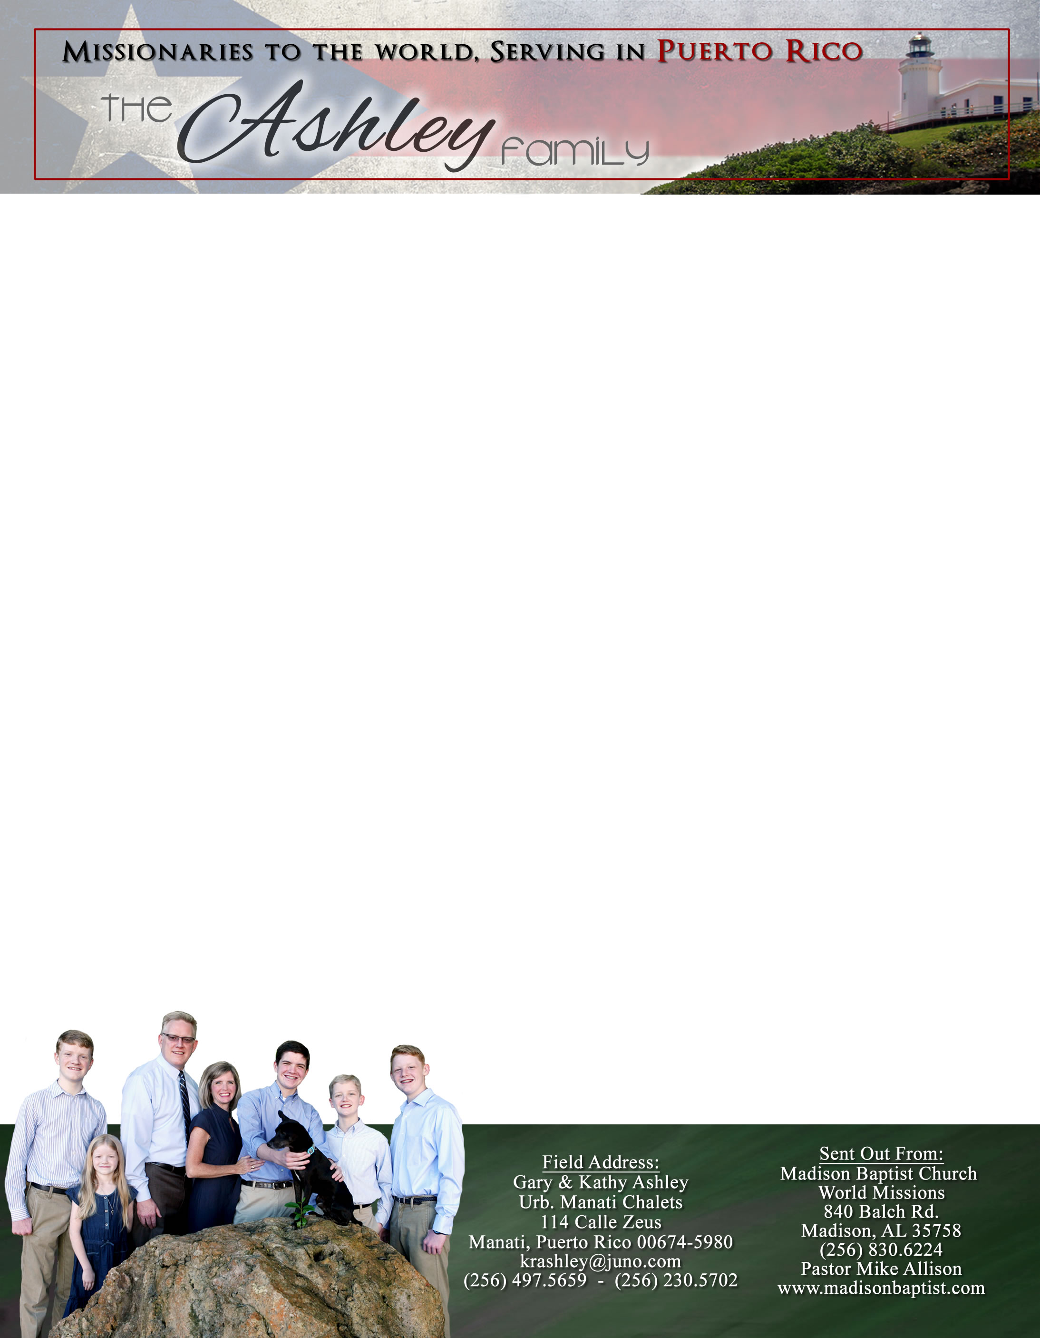 **Andrew & Freddy**

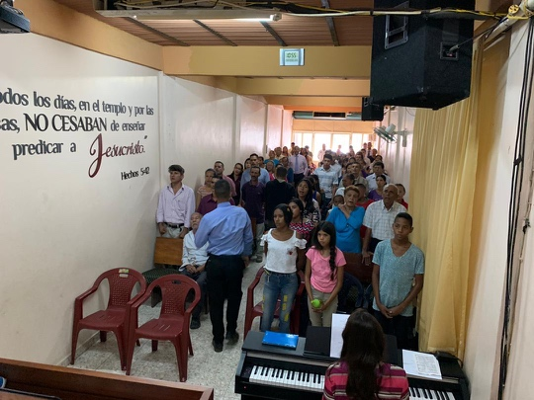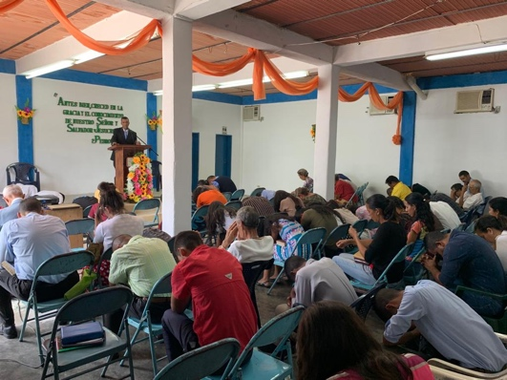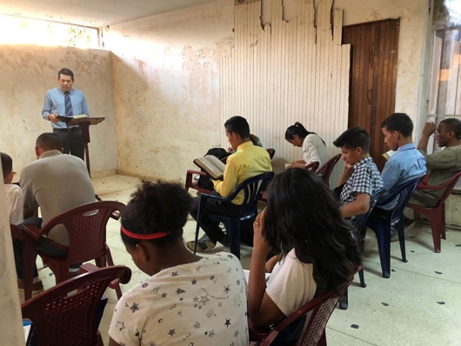

*Alaba al Señor*,

(Praise the Lord)

Gary Ashley

Dear Praying Friends, July / August 2019

**Philippians 4:20, “Now unto God and our Father be glory for ever and ever. Amen.”**

Our hearts are full of gratitude as we sit and count our blessings of these past months. This summer has truly flown by. We had many things on our project list as we have been stateside like getting Caleb, our second son, set up with living conditions, a car, a job, some ministries, and college classes. God has so abundantly provided! We had some unexpected surprises as well as we were able to see Klixon Castillo, the pastor of Bible Baptist Church in Valencia, Venezuela, as he was trying to raise some support. He came and stayed with us a few days while we were in a missions conference and Vacation Bible School. The fellowship was great! We are very thankful for the time spent with him prior to his return to Venezuela. He took advantage of his visa since he will not be able to leave Venezuela for a while unless the government lifts the restrictions. Lord willing, he can still get over to Colombia to get medicine for his kids. The Lord greatly supplied for him while he was visiting churches. We thank God for your part in this! Upon his return, he sent us photos of his church in Valencia, the church in Guacara that we helped start in 2004, and the Bible Institute that he started in Valencia in which many in the church in Guacara also attend. These churches continue to abound and our hearts overflow with joy to see God glorified through their lives.

Please pray for us as we leave the 27th of August to return to Puerto Rico. We desire to see God work in our church in Manati. We are thankful for Freddie who has faithfully filled in while we have been in the states. We pray that God will send a national pastor to take the church to help move the work forward, to expand the light of the glorious Gospel, and to edify the saints. We pray for wisdom in the coming days and for more sinners to come to Christ.