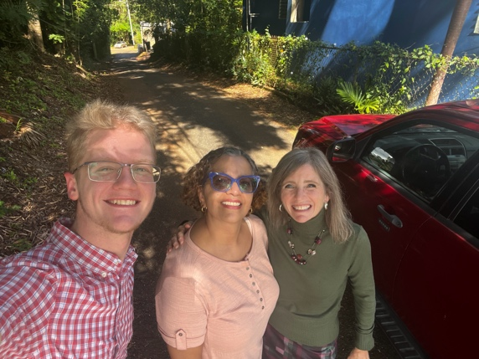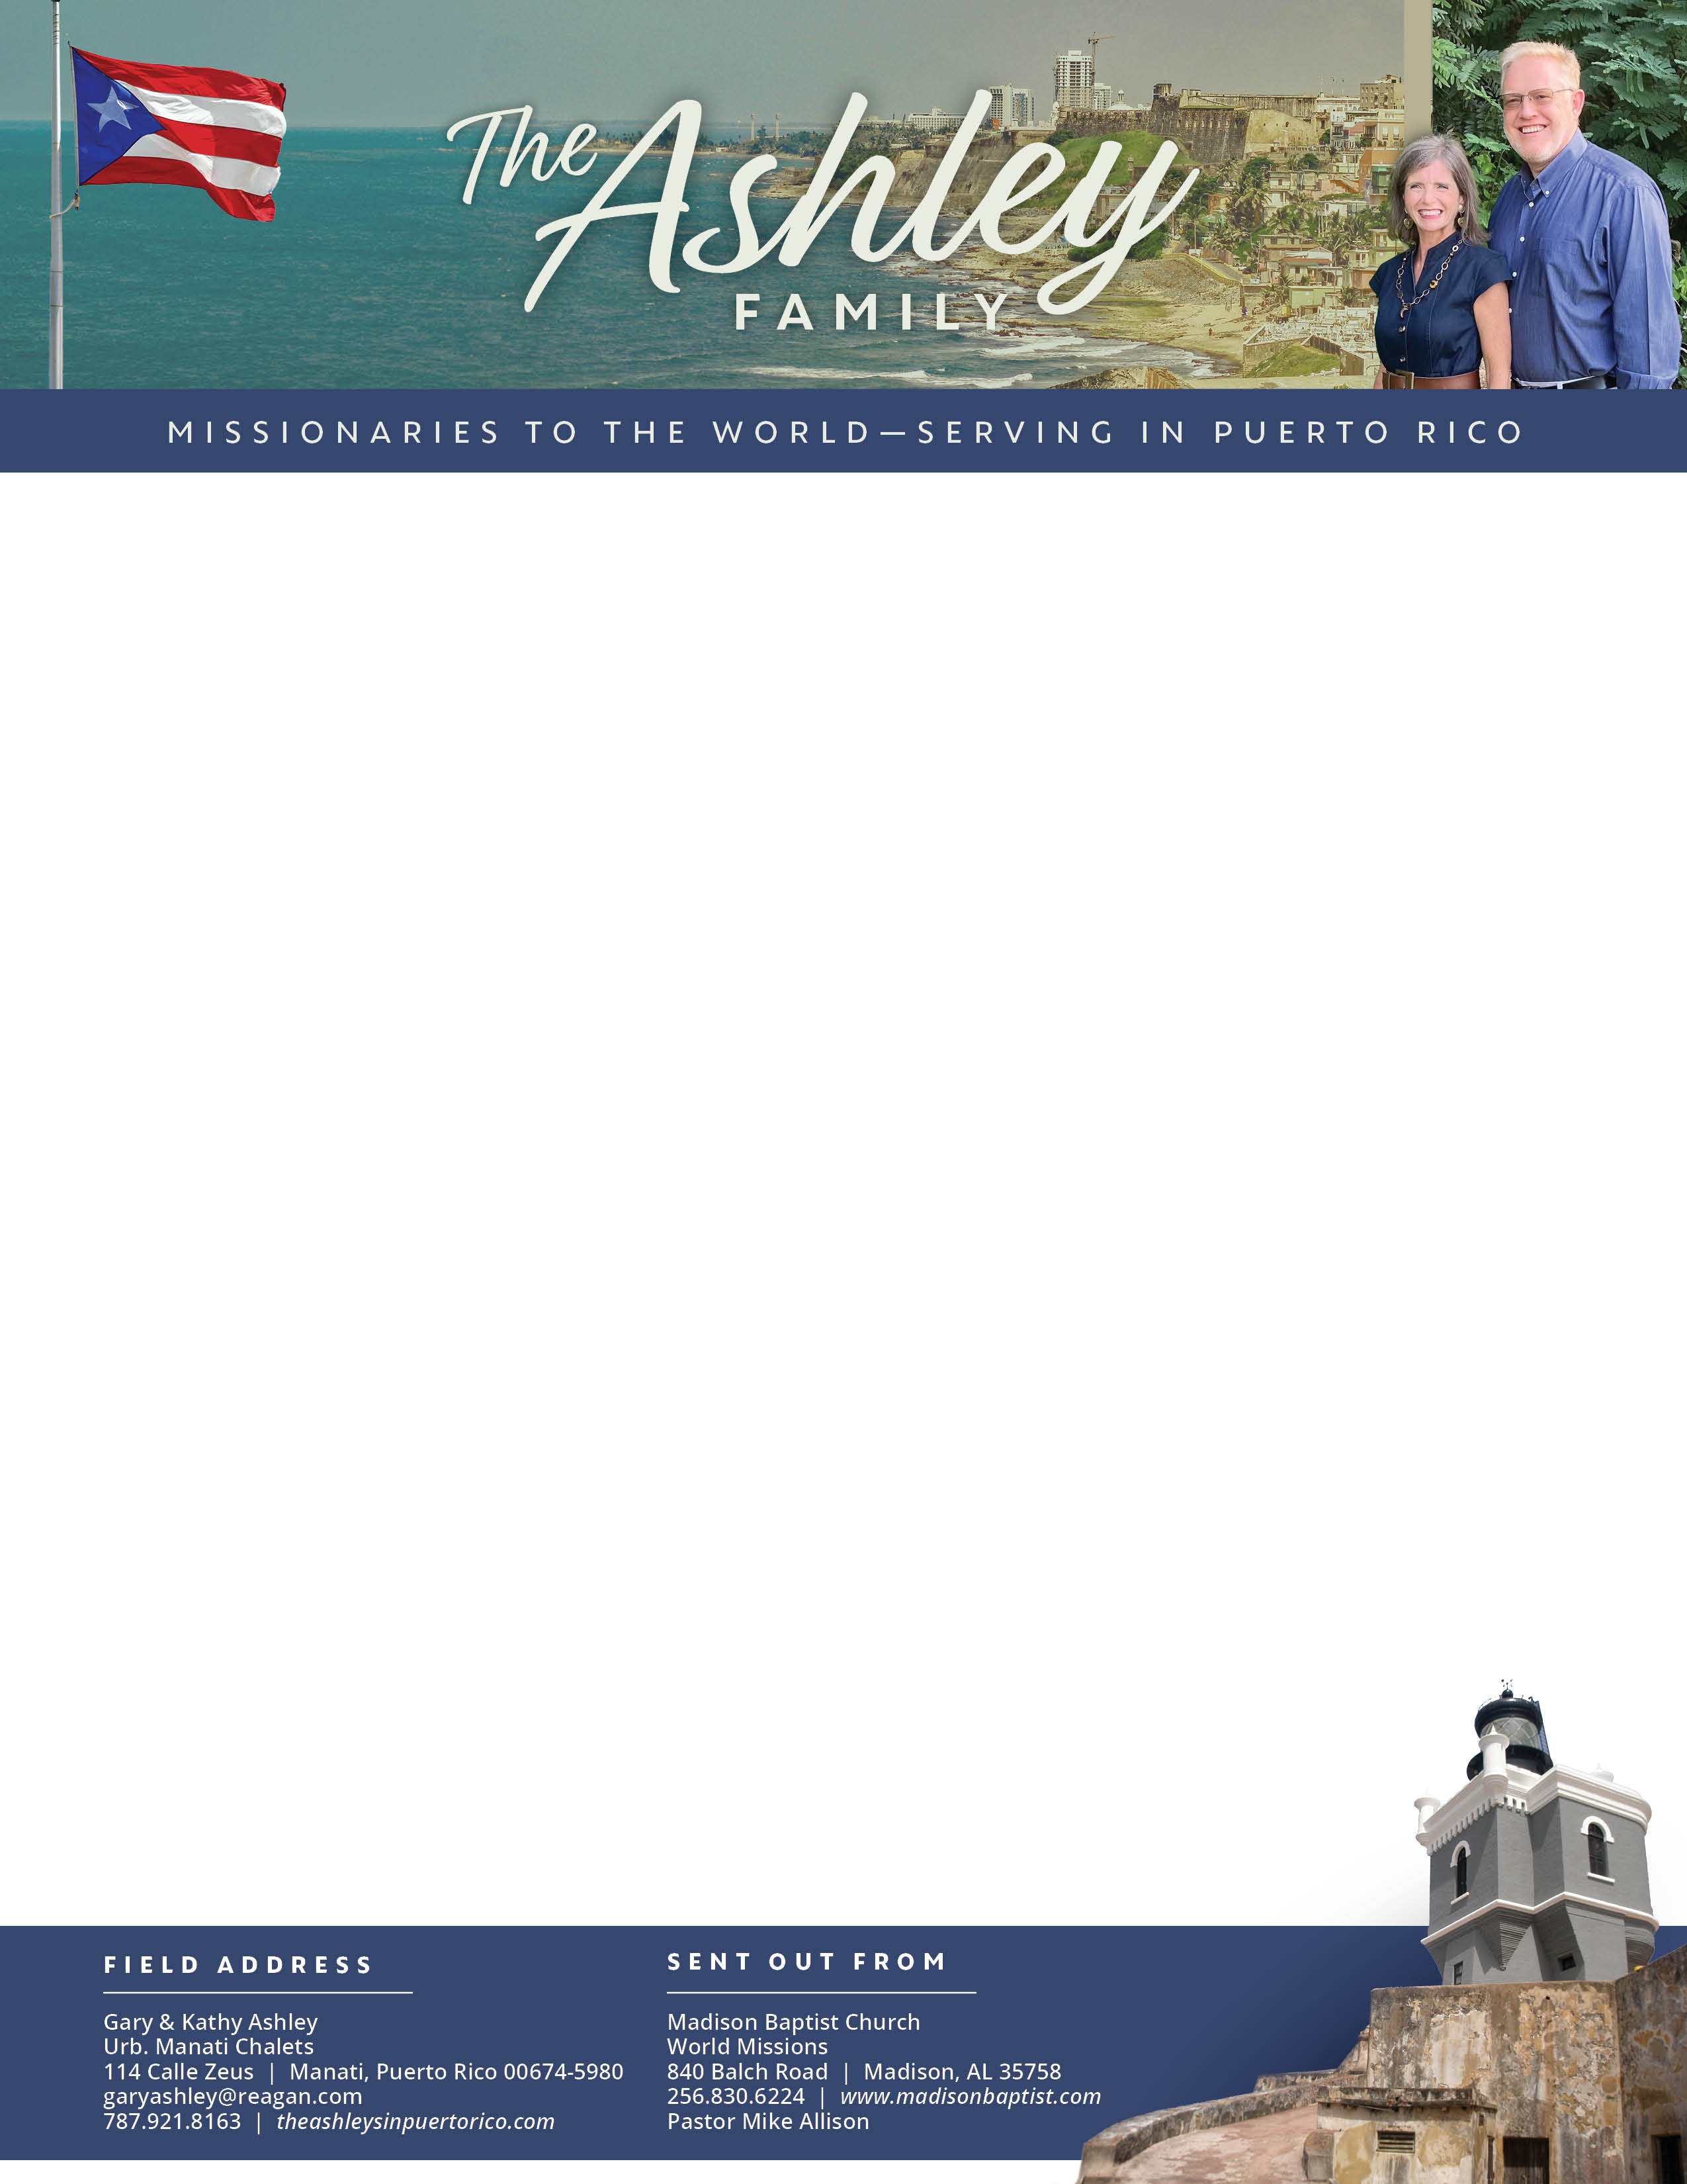

Gary Ashley

*Alaba al Señor*,

(Praise the Lord)

Dear Praying Friends, January / February 2024

**John 17:17 “Sanctify them through thy truth: thy word is truth.”** Today many are trying to live according to “their truth.” But, there is only one truth, and it is found in God. He has given His Word as the revelation of Himself; He is truth. We must have the revelation to know truth. The truth that is expressed in creation is not sufficient for salvation, though the heavens assuredly declare the glory of God. Psalm 19. In John 17, Jesus was praying for His sheep as well as telling His sheep where to find truth; they were to find it in His Word. If today there is a fight over truth and the definition of words, then we must have a standard for truth and from that learn what truth is.

The New Year has brought about new opportunities. A lady in the church, Rosemary, wanted to have a ladies’ Bible study and invited her mother, sister, and neighbor to attend. Kathy has been going ever week to her house and they have been working through Ms. Francie Taylor’s Bible study on Conditions of the Heart. It has been an encouraging time; they have thoroughly enjoyed the fellowship and teaching from God’s Word.

We continue to pass out tracts in the eastern section of the city of Manatí. Some receive the tract well and ask questions. Others graciously take the tract and close the door. Many are not home; we leave the tract in the gate. Our prayer is that these will be seed that will fall into the hearts of those that pass by. It was such a blessing to have Stephen home from Bible college to go with us.

Thankfully, Charlie has returned to visit again. We pray that he will continue to come, learn, and grow. We are excited to see what God will do in his life. Please continue to pray that the Lord sends more visitors, past members, and more opportunities to preach the gospel to the people in Manatí.