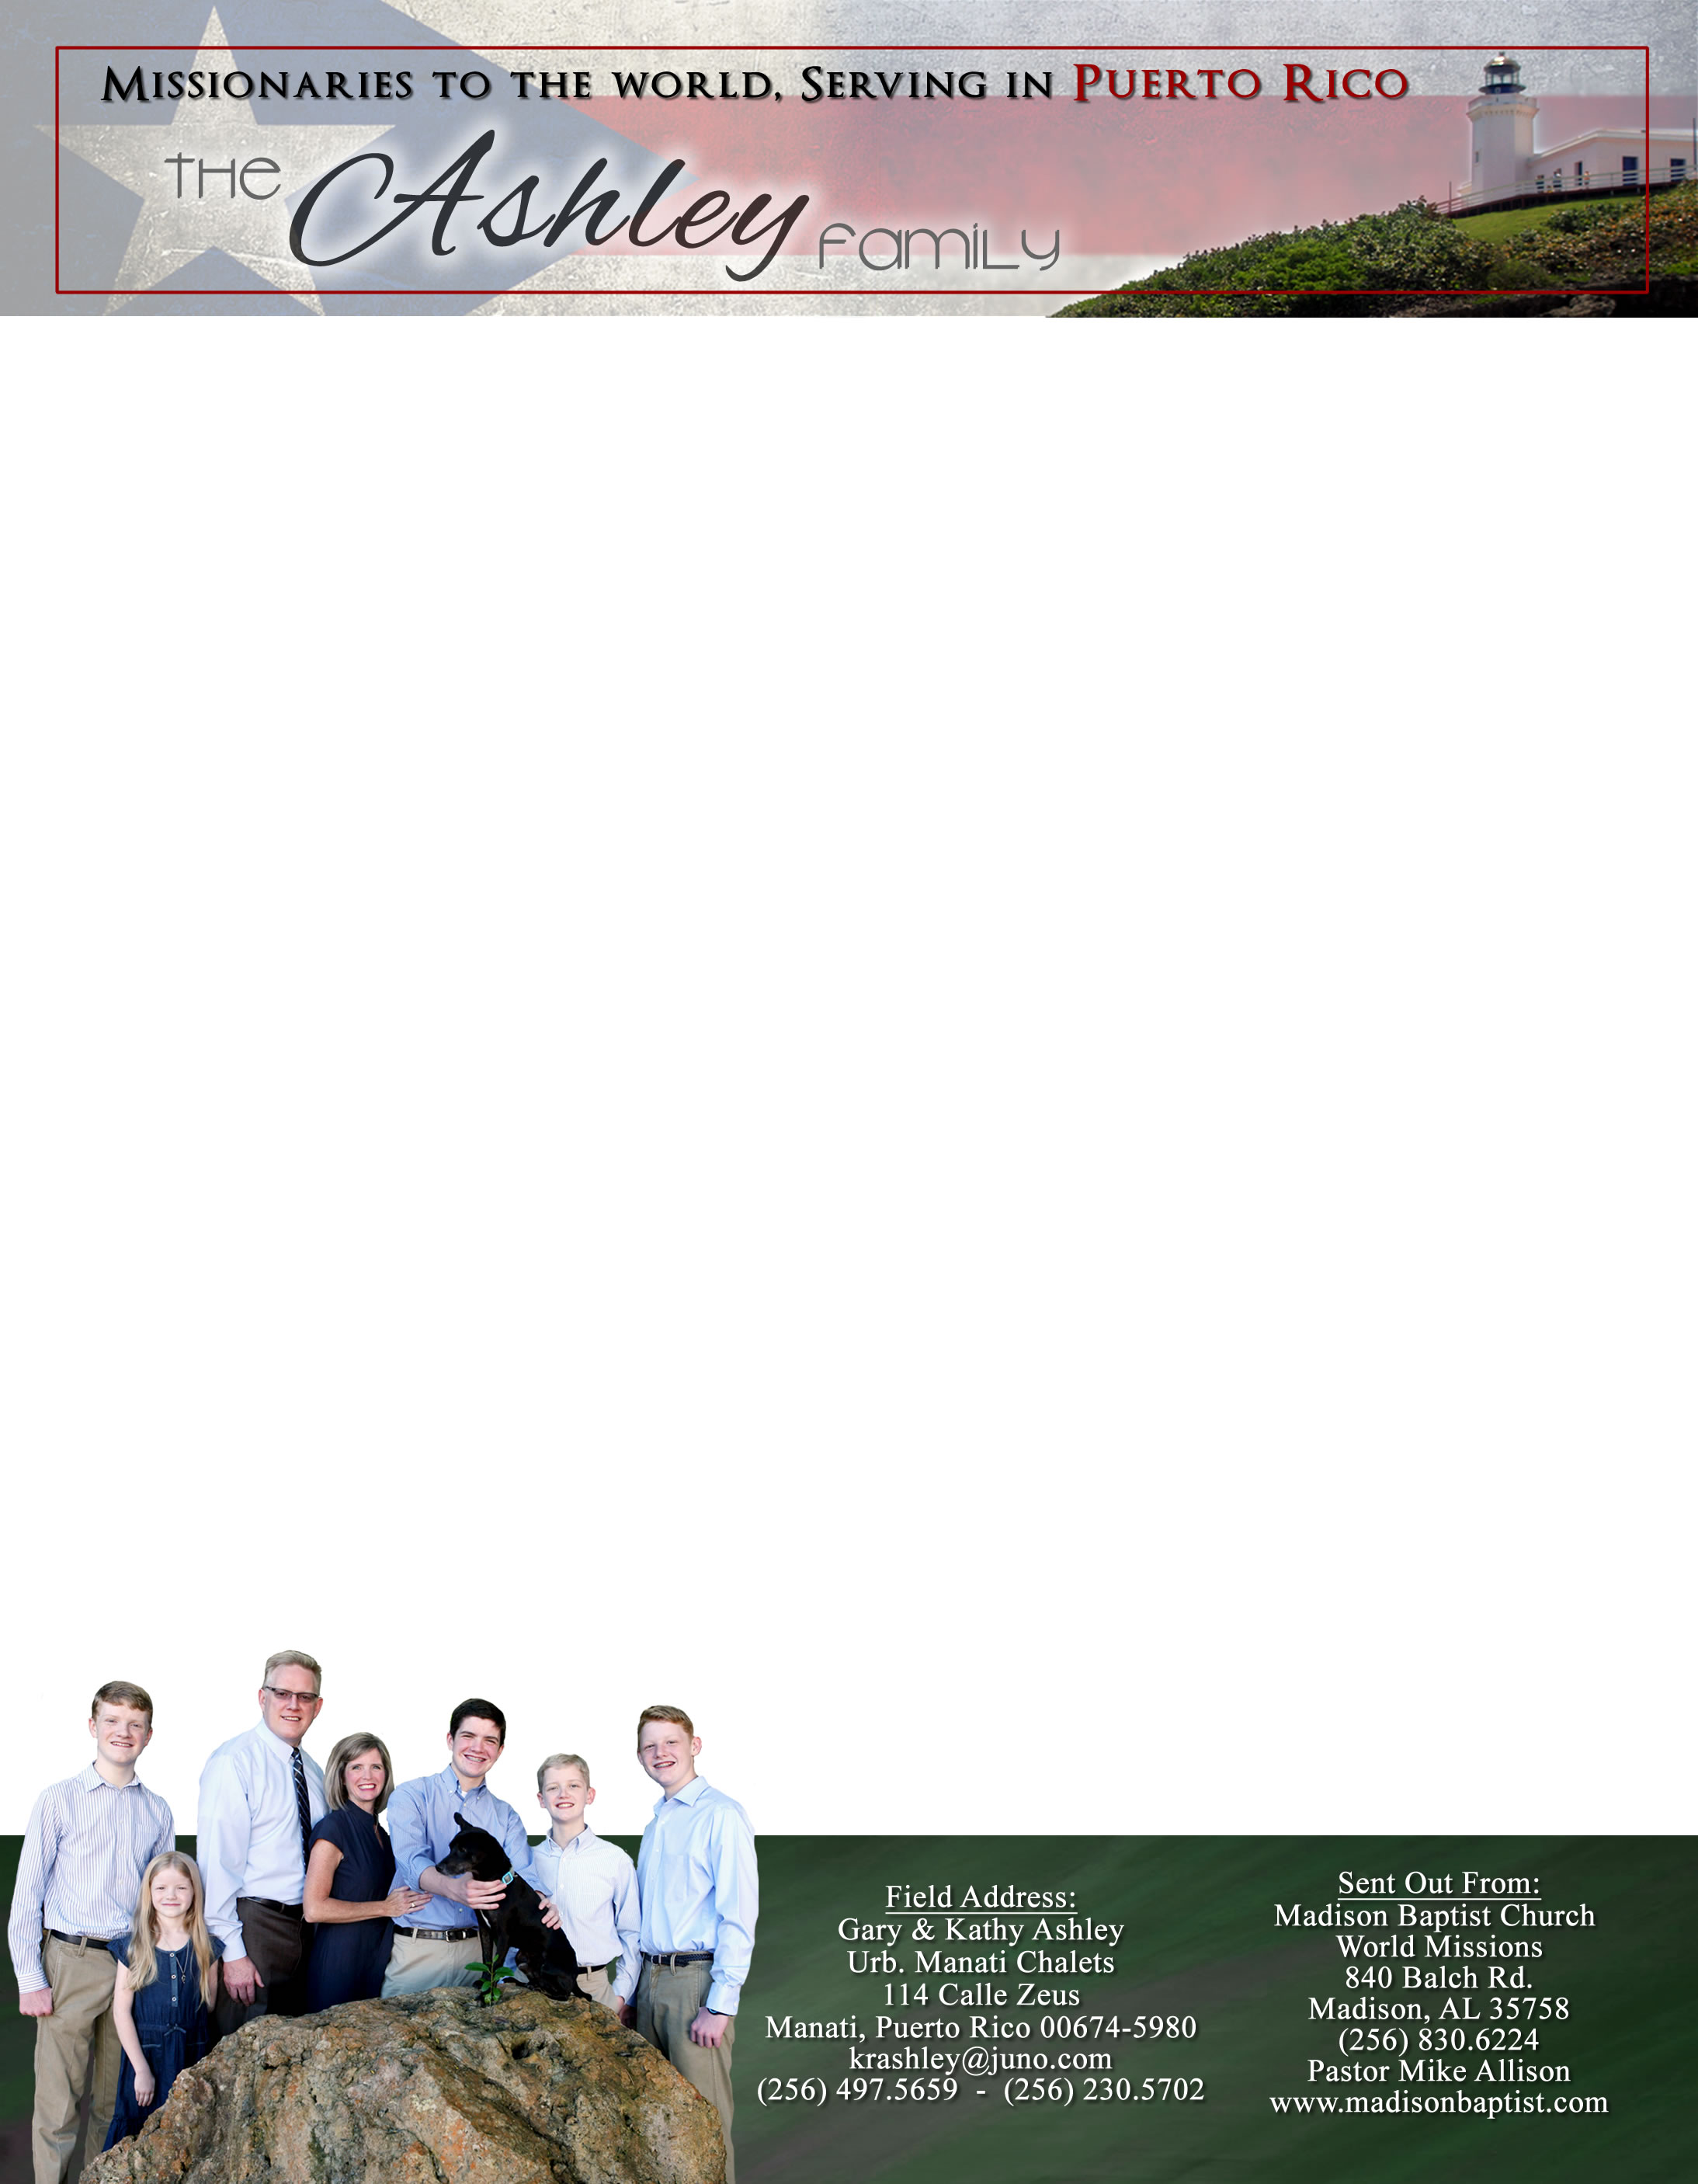 **Andrew & Freddy**

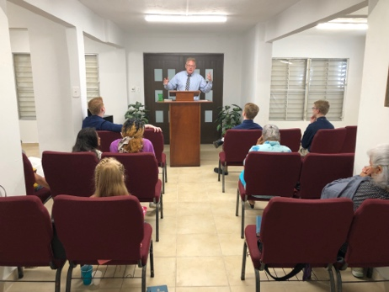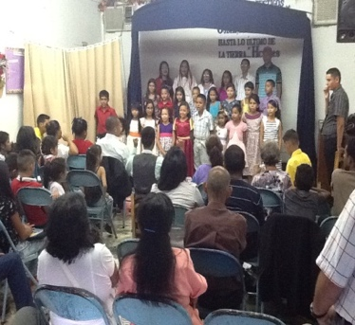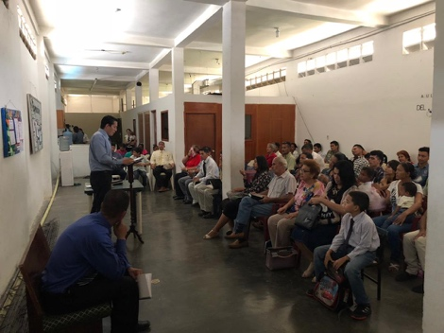

Dear Praying Friends, March / April 2019

**Romans 15:24 says, “Whenever I take my journey into Spain..."**

Paul’s desire was to go to new lands that had not been evangelized. His view of evangelism was to establish a solid, indigenous church rather than mass evangelism. He would return after his first imprisonment back to those very churches that he had already established because they were struggling. Our ministry has been to establish solid, indigenous churches where ever God leads us.

It began in Venezuela where now Klixon Castillo and Luis Quilarque are the pastors over solid, indigenous churches and are struggling with the horrible situation there. Please continue to pray for them and if it is possible, consider helping to buy them an electrical generator. Klixon can get them for about $1,000 each. Our next step was at Mount Calvary Baptist Church in Jayuya, Puerto Rico, which is a solid, indigenous church now with a Puerto Rican pastor and a finished building. We are attempting to bring this current church in Manati to that state as well. God has provided so much for this church for rebuilding after Maria through you. The second floor of the church is a house for a national pastor; it is almost completed. The whole building has been cleaned out, rewired, scraped, painted, and new signs with finances secured, and an atmosphere of growth created. We still have three bathrooms and two roof coverings over patios to finish. We also need the Lord to send a national pastor to take the work.

We will be back in the states May through August for Caleb, our second son, to graduate from high school. We will be setting him up for college with housing, a car, a job, and ministries in the church. While there, we will be traveling to some new churches but are available to visit any other churches that would like us to report in person. Feel free to call me at 256-497-5659. May God bless each of you as you seek to serve Him.

Gary Ashley Manati, Puerto Rico

Klixon Castillo Valencia, Venezuela

Luis Quilarque Guacara, Venezuela

*Alaba al Señor*,

(Praise the Lord)

Gary Ashley