 **Andrew & Freddy**

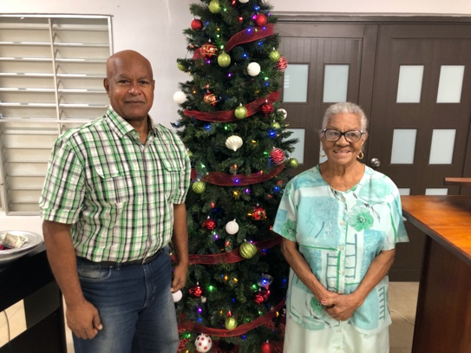

Merry Christmas! God bless you all as you seek to serve Him in this New Year!

God has blessed in this trying time ! Abraham has been able to bring Juana to church every Sunday. He has paid very close attention to each sermon and has been a blessing to get to know. God also sent Rosemary to visit us and hopefully will join us. The Girls’ Club continues with a great attendance and excitement for which we are thankful.

In Venezuela, we continue to thank the Lord for the growth of His people and the outreach that Klixon Castillo and Luis Quilarque have been able to have in their respective works. Klixon has bought a motorcycle which allows him to visit the church members and have meetings at their houses and in their communities. Though the government is very restrictive in what they are able to do, they have continued to find new ways to go forward. Luis Quilarque has been faithful in the work that we left in Guacara, and he has a new work in Naguanagua that has grown so much that they want to rent a new building to hold services in! It will cost about $240 as a down payment and then $80 a month to rent it, but it is ample space for the young church to meet and grow.

*Alaba al Señor*,

(Praise the Lord)

Gary Ashley

Dear Praying Friends, November / December2020

**Isaiah 41:8 says, “But thou, Israel, art my servant, Jacob whom I have chosen, the seed of Abraham my friend.”**

During the Christmas season we often think of the book of Isaiah and the many prophecies that are in this great book. Jehovah God chose the nation of Israel to be His people through which the Promised Messiah would come. Isaiah chapters thirty-eight through fifty-five are considered the servant songs and the servant of the Father Himself would be Jesus who was sent by the Father to save His people from their sins. Thankfully, it is far more than just Jacob and the nation of Israel that would be saved from their sins; it allows the Gentiles as well to receive His salvation. We thus celebrate Christmas as a day like no other when God in human flesh dwells with us and for our salvation. He is our Emmanuel!