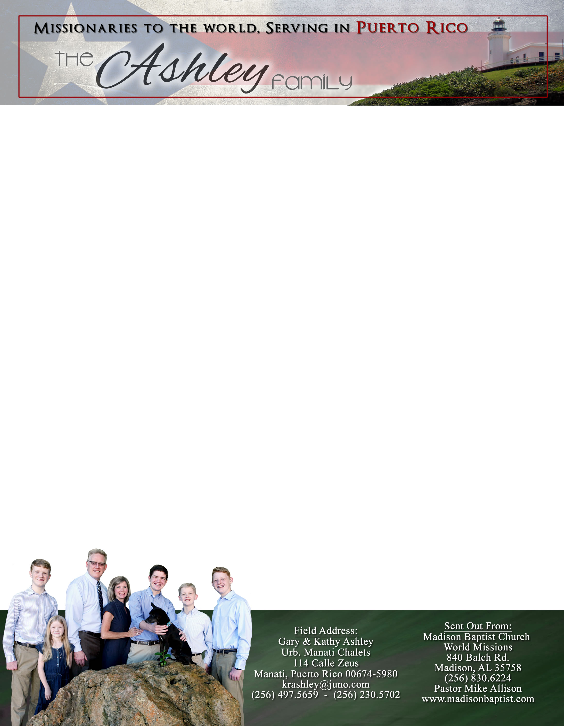 **Andrew & Freddy**

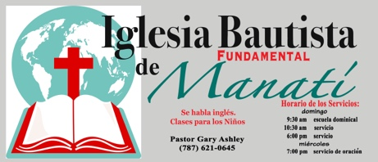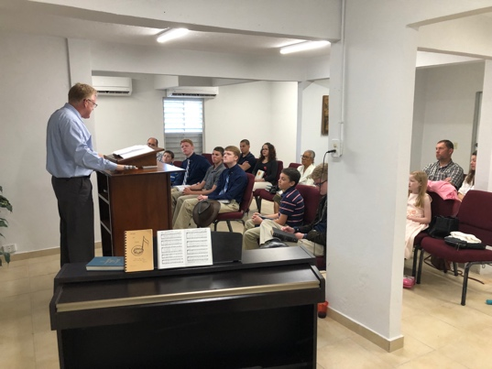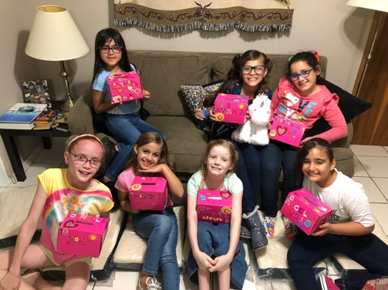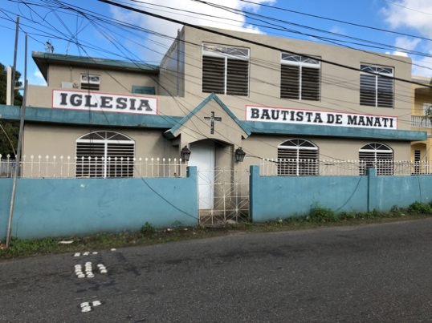

*Alaba al Señor*,

(Praise the Lord)

Gary Ashley

Dear Praying Friends, January / February 2019

**Haggai 1:8 says, “Go up to the mountain, and bring wood, and build the house; and I will take pleasure in it, and I will be glorified, saith the Lord."**

Puerto Rico has rebuilt herself in many places after Hurricane Maria. We purchased signs for the church, and a Yamaha Clavinova for our music. We are so thankful for those churches that gave extra money to do this! We found a painter who made the sign on the front of the church building and desired to paint the rest of the building! Of course, we let him. The Lord moved upon the city to clean up the three huge piles of trash from the destruction of over a year ago. We are still amazed each time we enter the building to see what God has done and what He has provided. We still need to retile the bathrooms which will be about $3000 and put on roofs over the patios for about $2000, and we now need bars for security because these repairs have attracted thieves. Now, we need to reach the people!

The Girls’ Club has increased with a few more girls. They are learning Bible songs in Spanish and English as well as Bible stories. We desire to reach their families with the Gospel.

Please pray for Venezuela as the turmoil has worsened. The pastors and people are hurting. We have kept in contact with Klixon Castillo; God has provided for them and protected them. Please remember his church in Valencia and Luis Quilarque in Guacara in your prayers.

We also must return to the States in May for the summer as our second son Caleb will be moving back to Alabama to go to college and attend Madison Baptist Church. We must set him up with a job, college, a place to live, and a car. If your church would like us to come by, please contact me at 256-497-5659. We had to get rid of our email [krashley@juno.com](mailto:krashley@juno.com) because it was hacked; you can reach us at krashley@hotmail.com.