



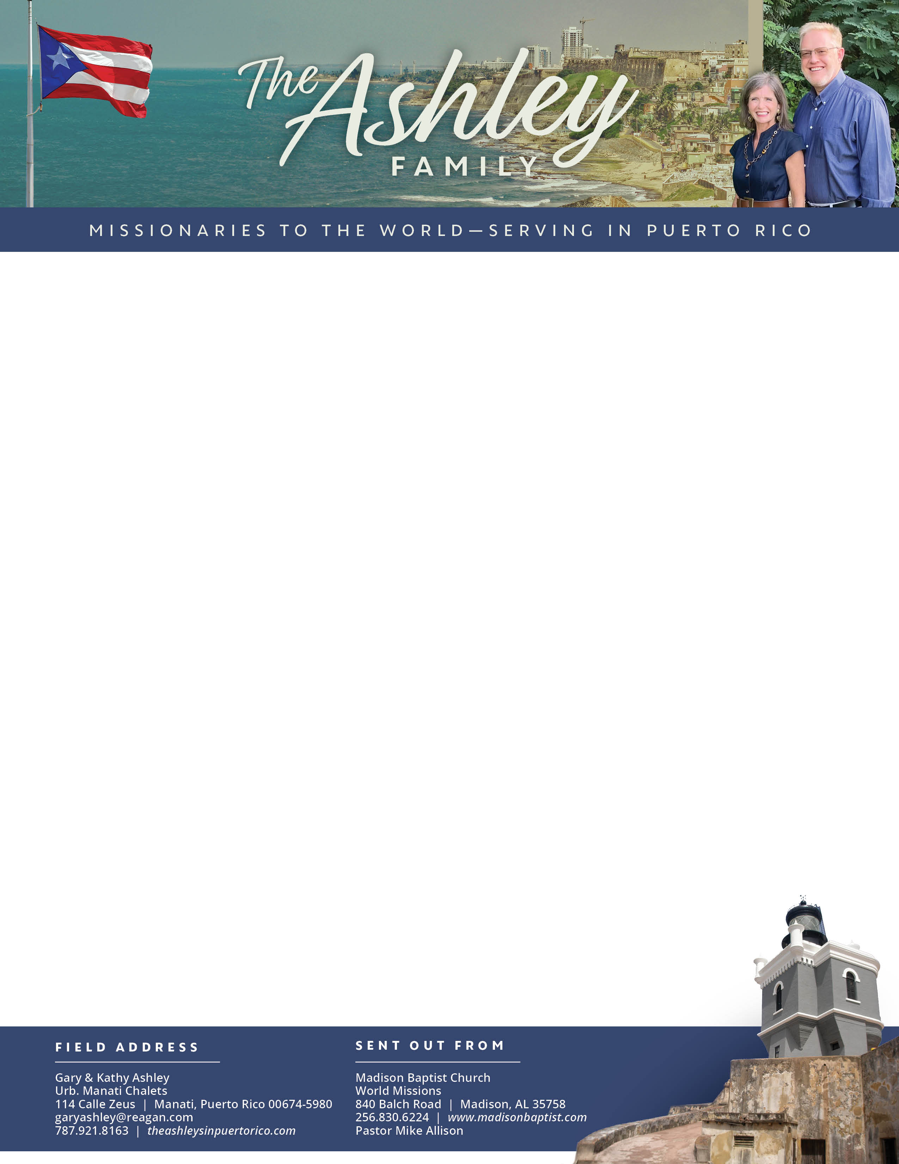
Prayer Requests: 1. For Juancho with his many eye surgeries. 2. For Charlie as he is gone for 9 months as merchant marine. 3. For Jenna, Charlie’s daughter, to attend church. 4. For the outreach of tracts to bring new comers.
Gary Ashley

Alaba al Señor,
(Praise the Lord)
Dear Praying Friends, May / June 2025
II Timothy 4:13 “The cloke that I left at Troas with Carpus, when thou comest, bring with thee, and the books, but especially the parchments.” Paul had sent out his co-laborers to different locations while he was still in prison. He requested of Timothy his company, a cloke, books, and parchments. This set a great example for all workers in God’s kingdom; to be approved unto God one should study God’s Word with good books in order to advance in his understanding and to glorify God. Making God the focus of our preoccupation is the best way to advance missions.
We have been amazed at God’s Providence in these past few years with the publication of some books that Kathy has written for ladies’ Bible study. She has a set of three that are similar in studying a passage of the Bible and applying it to the spiritual life; then she has another on the prayers that were prayed through the Bible with truths that can be learned. If any lady or group of ladies are interested, the books can be found through the Sword of the Lord publishers website, Ms. Francie Taylor’s online bookshop, or even on Amazon Kindle for those e-readers.
For copies of each prayer letter and/or photos of current activities in the ministry, please check out our website: https://www.theashleysinpuertorico.com

