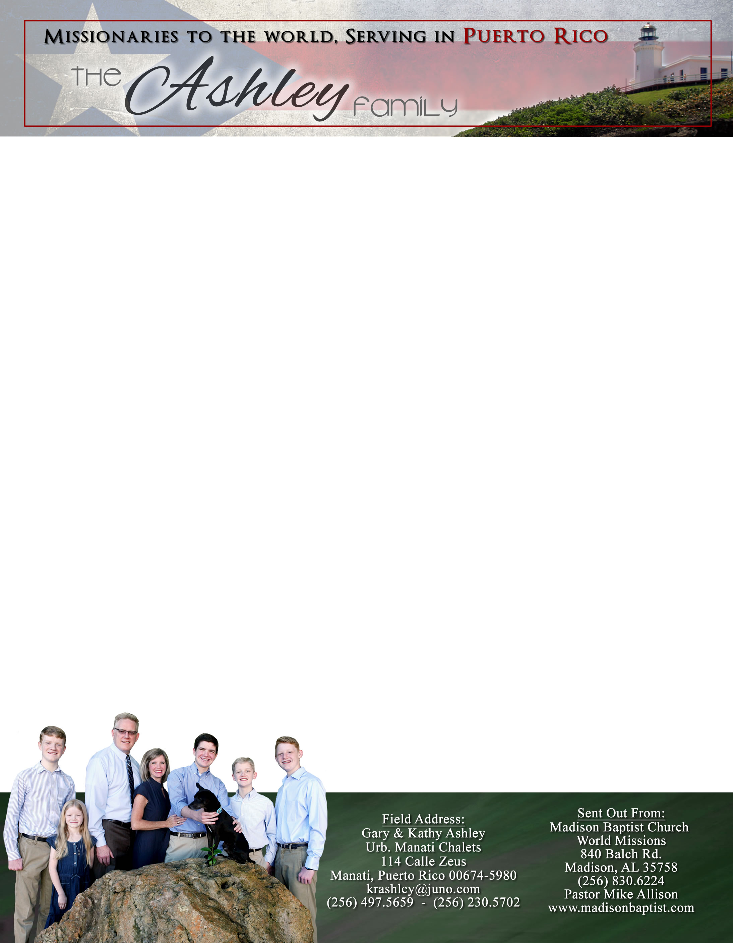



Dear Praying Friends, September / October 2022

**Acts 27:14 “But not long after there arose against it a tempestuous wind, called Euroclydon.”**

Luke continued the report about the fourth missionary journey to Rome and the kings or Caesar by mentioning in v. 18 the tempest which caused them to be tossed and to lighten the ship further in precaution and further preparations. When we sign up for passage on the boat of life we do not know what the journey will entail until it is over except for Paul; he knew he had been promised the opportunity to preach to kings. All that we can do is lighten the ship. We praise the Lord that many churches and individuals have come along side of us and helped lighten the load.

For us on the island of Puerto Rico, September through October is hurricane season. Of course, for many coastal states in the US it is the same for them, too. Two major ones have passed us this year, but neither compare to Hurricane Maria from 2017, five years ago. As we reflect on that event, we praise the Lord over and over for His protection and great provision since. The damage from Maria as a category four was enormous; yet God provided about $35,000 for repairs along with workers to do the jobs. We still need to repair the bathrooms at about $3000 a piece and the kitchen upstairs. This year, we experienced another hurricane as Fiona a category one, and Ian as it passed. We did not miss any church services, and everyone was safe and provided for. Our area of the island lost power for a week which caused us to lose water as well, but with a generator and a cistern, we wisely rationed the electricity and water. The only other concern was flooding, but outside the front of the church we have corrected that problem as well and the church suffered no water damage. Praise the Lord!

We are excited to still hold services, go door to door witnessing, and even continue Girls’ Club in the neighborhood. We do pray for those that have lost homes,

belongings, and even loved ones throughout these storms.

Many countries in the Caribbean and the Gulf of Mexico have

been affected this season.

Please continue to pray for our witness to be effective and the

believers in the church to grow. We desire to see more come

to know Him through our ministries. We serve a great God!

*Alaba al Señor*,

(Praise the Lord)

Gary Ashley