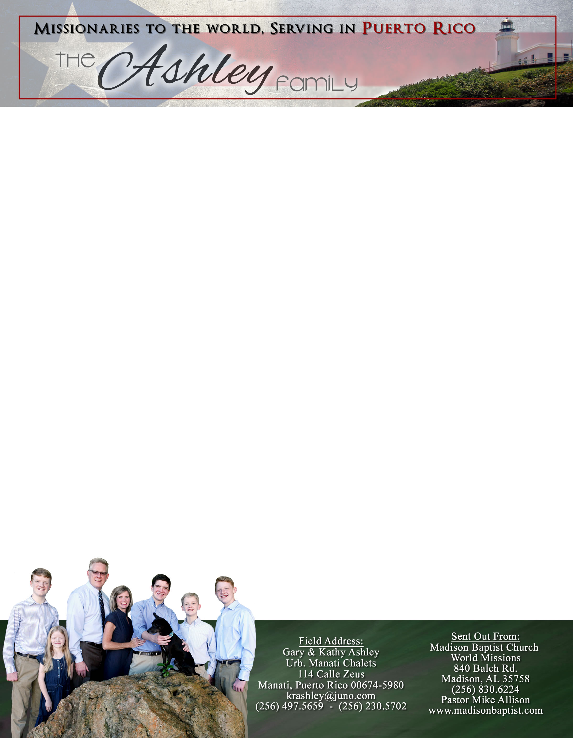

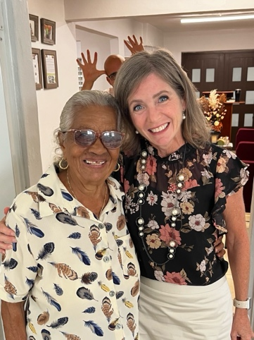

*Alaba al Señor*,

(Praise the Lord)

Gary Ashley

Dear Praying Friends, September / October 2023

**Micah 7:18 “Who is a God like unto thee, that pardoneth iniquity, and passeth by the transgression of the remnant of his heritage? He retaineth not his anger for ever, because he delighteth in mercy.”**

This passage is a beautiful description of the only Triune God. The word *nasa* as used means to lift, to carry, or to take. This idea is quite contrary to what the god Allah does who is said to pardon arbitrarily. Instead, the True God put our sin on His Son Jesus, and He lifts, carries, and takes away our sin so that this is not like a writ by a governor to pardon but rather is like our kinsman redeemer taking our place. This brings us back to the beginning of the verse saying who is a God like unto Thee? What a thanksgiving and also a praise for Who God is! Moses in Exodus 34:6-7 names God in this same way. What a merciful God we serve!

We thank the Lord for putting us in His service as missionaries over twenty-five years ago. There have been many ups and downs beginning with deputation, language school in Mexico, being forced to leave Venezuela, etc. But those ministries have continued to flourish without us; God has shown Himself faithful. As we arrived in Puerto Rico in 2008 our house was full; now we are almost empty-nesters. We have survived two great hurricanes, several earthquakes, and for me, gastro problems, detached retina, and major finger surgeries, but God has worked in our small church and it is more solid than ever. Jesus’ disciples came back from an eventful mission with stories of amazing acts, the Lord Jesus topped their stories with saying he saw Satan fall but the key is rather that they should praise God that their own sins were forgiven. Much like in Micah 7:18, our Triune God is the only God that pardons iniquity and carries guilt. I still cannot get over the day He lifted me from sin and shame and carried me over.

We continue to pray for our visitation efforts to bring in new folk, lead to the salvation of the lost, baptisms, and church membership as we continue to try to reach the entire city

for Jesus going door to door. Pray for me personally as I have been undergoing

several different health problems at once with two finger surgeries, and three

eye surgeries. I did not think that at fifty-something years old, I would fall apart! But,

Hallelujah!, God remains the same: faithful, merciful, gracious, and good.