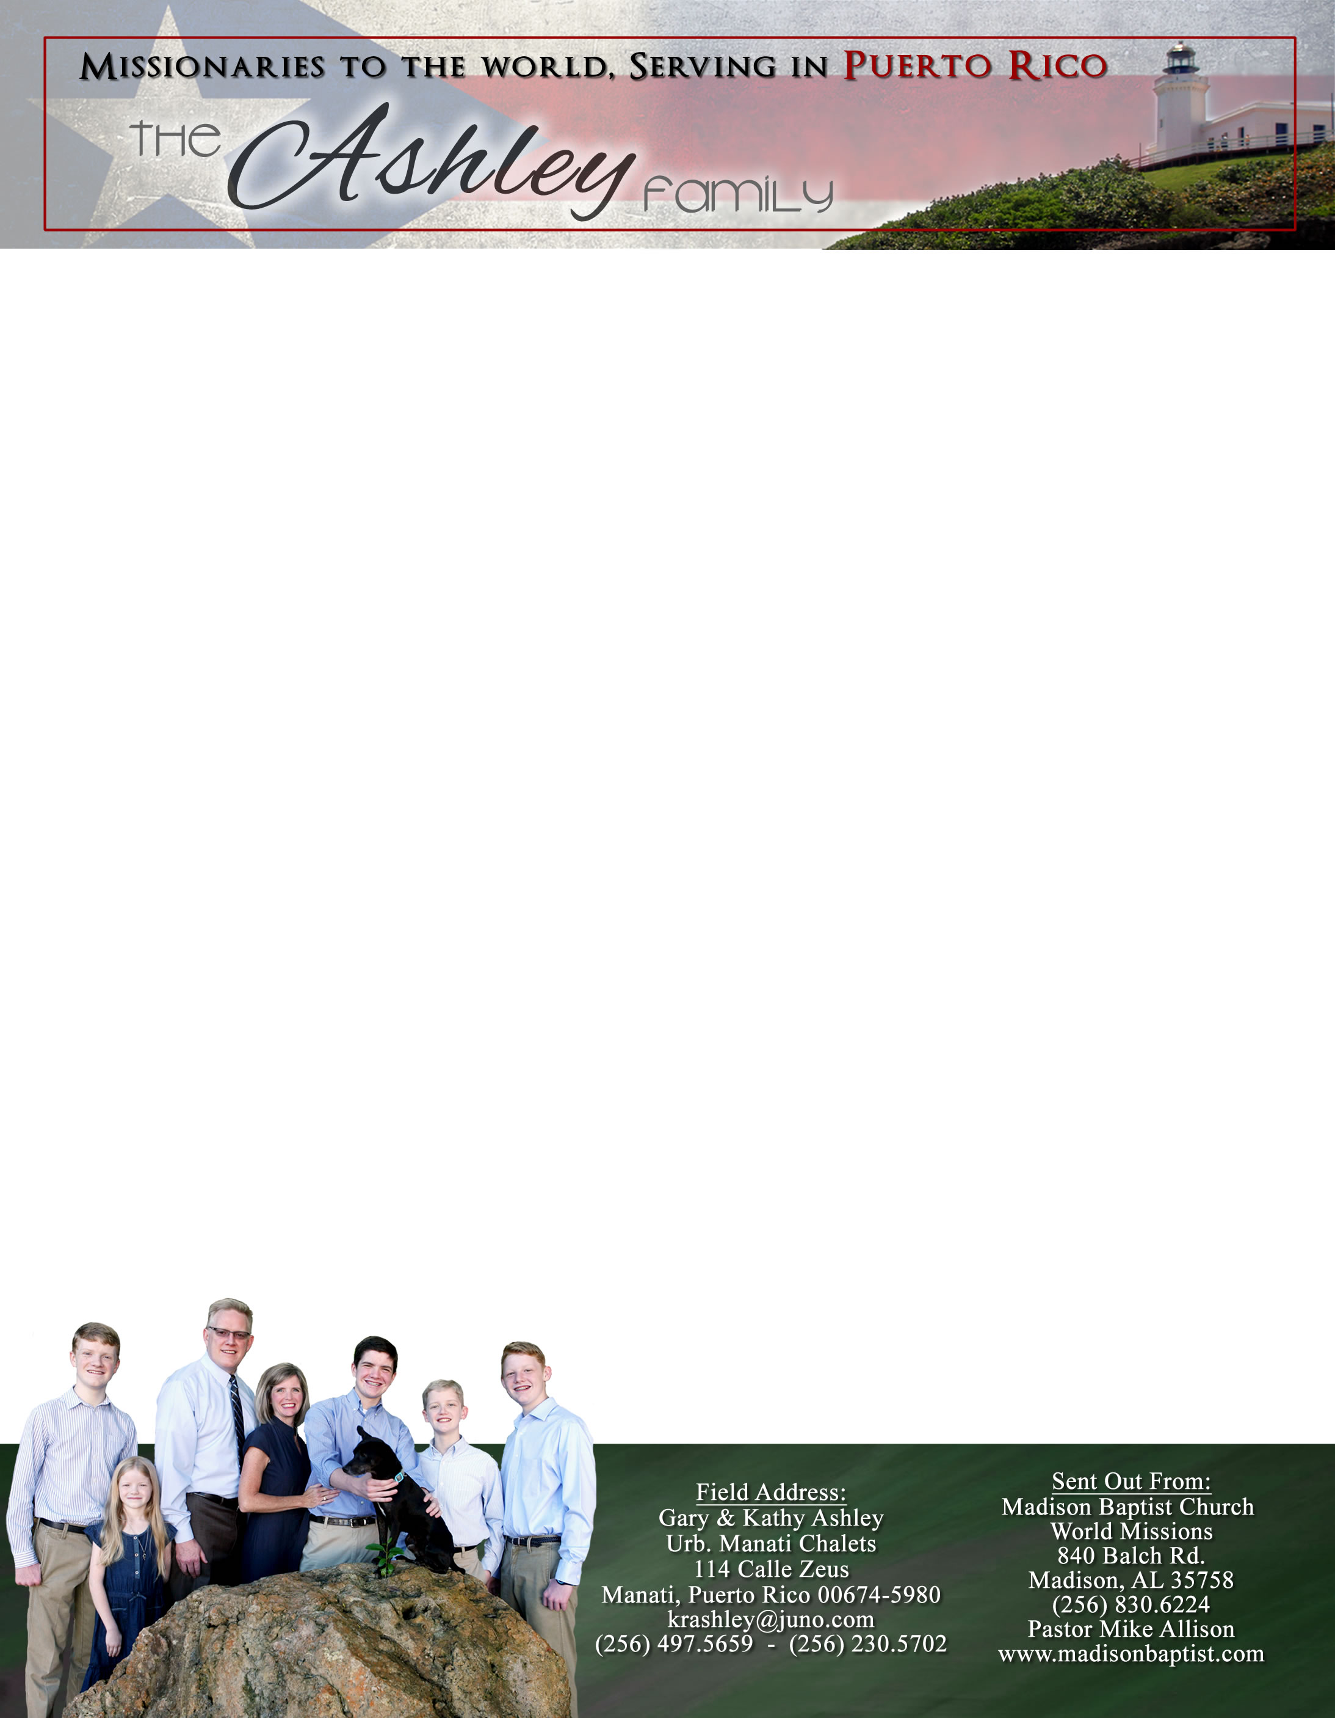

*Alaba al Señor*,

(Praise the Lord)

Gary Ashley

Dear Praying Friends, May / June 2023

**Psalm 31:23 “O love the Lord, all ye his saints: for the Lord preserveth the faithful, and plentifully rewardeth the proud doer.”**

In this Psalm, David had been in despair, but God lifted David’s spirit. Because of that, David could lift the spirits of those around him. In verse twenty-four, David could command and exhort his people to be of good courage because God had already raised him. Since God had raised up David they could hope in the same for they were God’s own people and David’s neighbors. Paul seems to have picked up this idea with saying we have both died and risen in Christ. How wonderful it is that this can be applied to our lives today! We have been handing out tracts and fliers through the city since the middle of the panic of Covid to now. We have talked to many people, but sadly have seen few results. God has encouraged me in this struggle. We are covering the city house by house, we have seen our people grow stronger, and we have had some results. We continue to pray for more results and desire that you pray for that as well. We, though, are encouraged by our strengthened hearts. Just two days ago, a lady called me and we spoke about the church and perhaps she will visit. As we finish one neighborhood, we move on to the next. Always forward.

Currently in Venezuela: This time has been difficult for both Luis Quilarque at Liberty Baptist Church in Guacara, and Klixon Castillo at Bible Baptist Church in Valencia due to the rolling blackouts that are occurring almost daily. Our church here in Puerto Rico has sent them both offerings. There is an abundance of gas; they just need the containers appropriate to fill for their generators and run their air conditioners and any other appliance. We praise the Lord for their faithfulness these past fifteen years since we left and the bountiful blessings that He has poured out on them. We are excited that we can be a part of their churches, their ministries, and their faithfulness still amidst these very difficult times.

In August we will be taking Stephen to Heartland Baptist Bible College for fall semester to pursue a degree in missions. He is excited and nervous. Pray for his settlement in the “unknown” to him. Pray that the Lord will open doors for our getting him there.

Please pray for Ileana. Kathy and Abigail were finally able to find her

and encourage her in the Lord. We long to see the Lord work in these

people’s lives. He is worthy!