 **Andrew & Freddy**

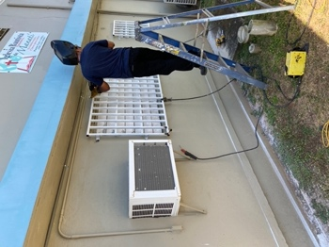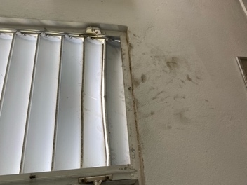

*Alaba al Señor*,

(Praise the Lord)

Gary Ashley

Dear Praying Friends, May / June 2021

**Psalm 5:2 says, “Hearken unto the voice of my cry, my King, and my God: for unto thee will I pray.”**

We tend to forget that God actually answers prayer, or we tend to live with a faint hope that He just might answer it rather than a firm assurance that He will. David the king went to the greater King and pled his cause. David had all that power and right and yet that could not help him for only materialists think that this that we see is all that is in the world. Too often the thought that techniques and plans can solve all problems is predominant instead of first going to the King of Heaven.

Through the years that I have been pastor here in Manati, we have had multiple attempts to rob the church, but they have never been able to get into the building until two weeks ago on a Saturday morning. They broke a hurricane shutter window and slipped in. They helped themselves to some things in the refrigerator, leaving the trash on the table. They opened the front door from the inside and stole the computer, the portable electric generator, the new lawn mower, the weed eater, the extension cord, the Peavey speaker, tools and the new tool chest. Immediately I began looking for an iron worker to make bars for the windows and a gate for the front door. Abraham helped me find a man that installed bars on five windows and the front door for $800 within 7 days! Praise the Lord!!

Praise the Lord that the thieves did not take more and did not vandalize the building. We have a keyboard for church services, and they did not take that. Praise the Lord that the men in the church knew who could help us fix the problem quickly! Perhaps these needed to be done years ago, but we are excited for God’s provision and protection now. We have gotten an estimate for the remaining twelve windows on the bottom floor of the church building. It will be $1,200. Perhaps in the future we will be able to complete this project.

We also had a visitor, Ester! She promises to return. God has been so good to us through all the different experiences we have had. We know He will continue.