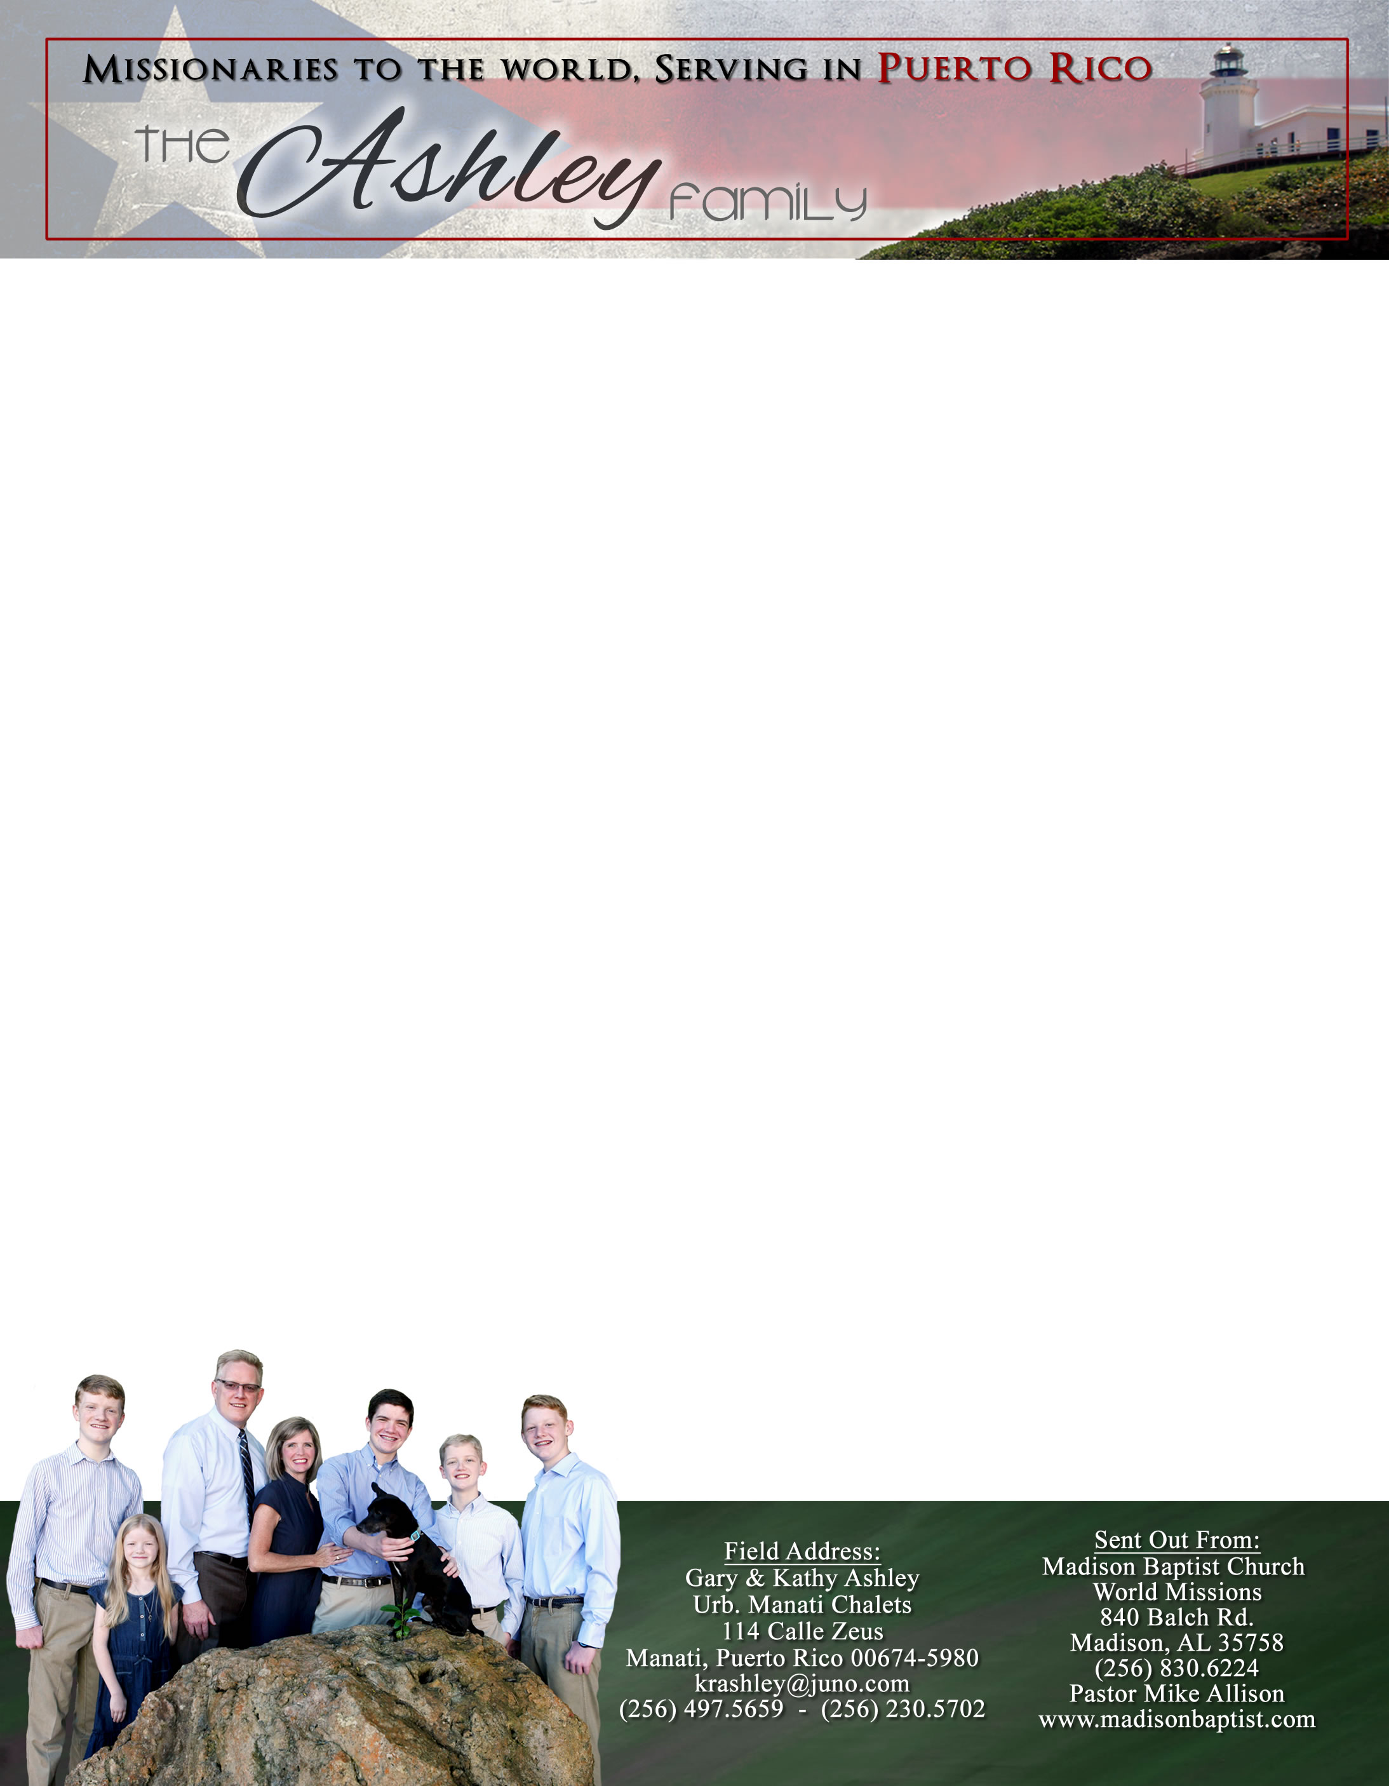

*Alaba al Señor*,

(Praise the Lord)

Gary Ashley

Please pray that God would be pleased through our efforts to witness, to see more people come to Him in salvation, baptism, and church membership. Isaiah 52:7 says, “How beautiful upon the mountains are the feet of him that bringeth good tidings…. That publisheth salvation.”

We in Puerto Rico were so excited to have with us one of our missionaries to Venezuela, Klixon Castillo. It was he, Carlos, and his mother Judith along with Pastor Julio Velasquez and me who began Liberty Baptist Church in Guacara in the front room of his house which soon moved to the garage outside. Since then, Luis Quilarque has had the church for over fourteen years and it has multiplied over and over. They have purchased the building, started a sister church, and have many other missions. Though these buildings and living conditions are “rustico” (bare-boned) as the economy has been in difficult times, yet God calls this church and these people beautiful! Our church has had the opportunity to help these men do God’s work in Venezuela. We praise the Lord for the privilege to work with humble men of God and enjoy the fellowship of the brethren. Not many mighty or noble are called but he has made them just that.

Dear Praying Friends, May / June 2022

**Ecclesiastes 3:11a says, “He hath made everything beautiful in his time: also he hath set the world in their heart...”**

It has often been said that beauty is in the eye of the beholder; but that is not true, for God defines what is beautiful. He who created all, also names, and owns all; therefore, He defines what is good and evil, beautiful and ugly. Wicked man wants us to celebrate with him in what he calls beautiful, but has rejected God who has set the world and eternity in the heart of man. Man tries to elevate himself to the level of God and then tries to require the rest of us to worship him and his perversions. Man wants us to say everything is beautiful in its own way, but we must respond by saying that God has set the limits on all things and defines them Himself. We are what He says we are.