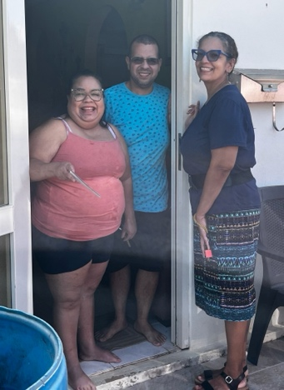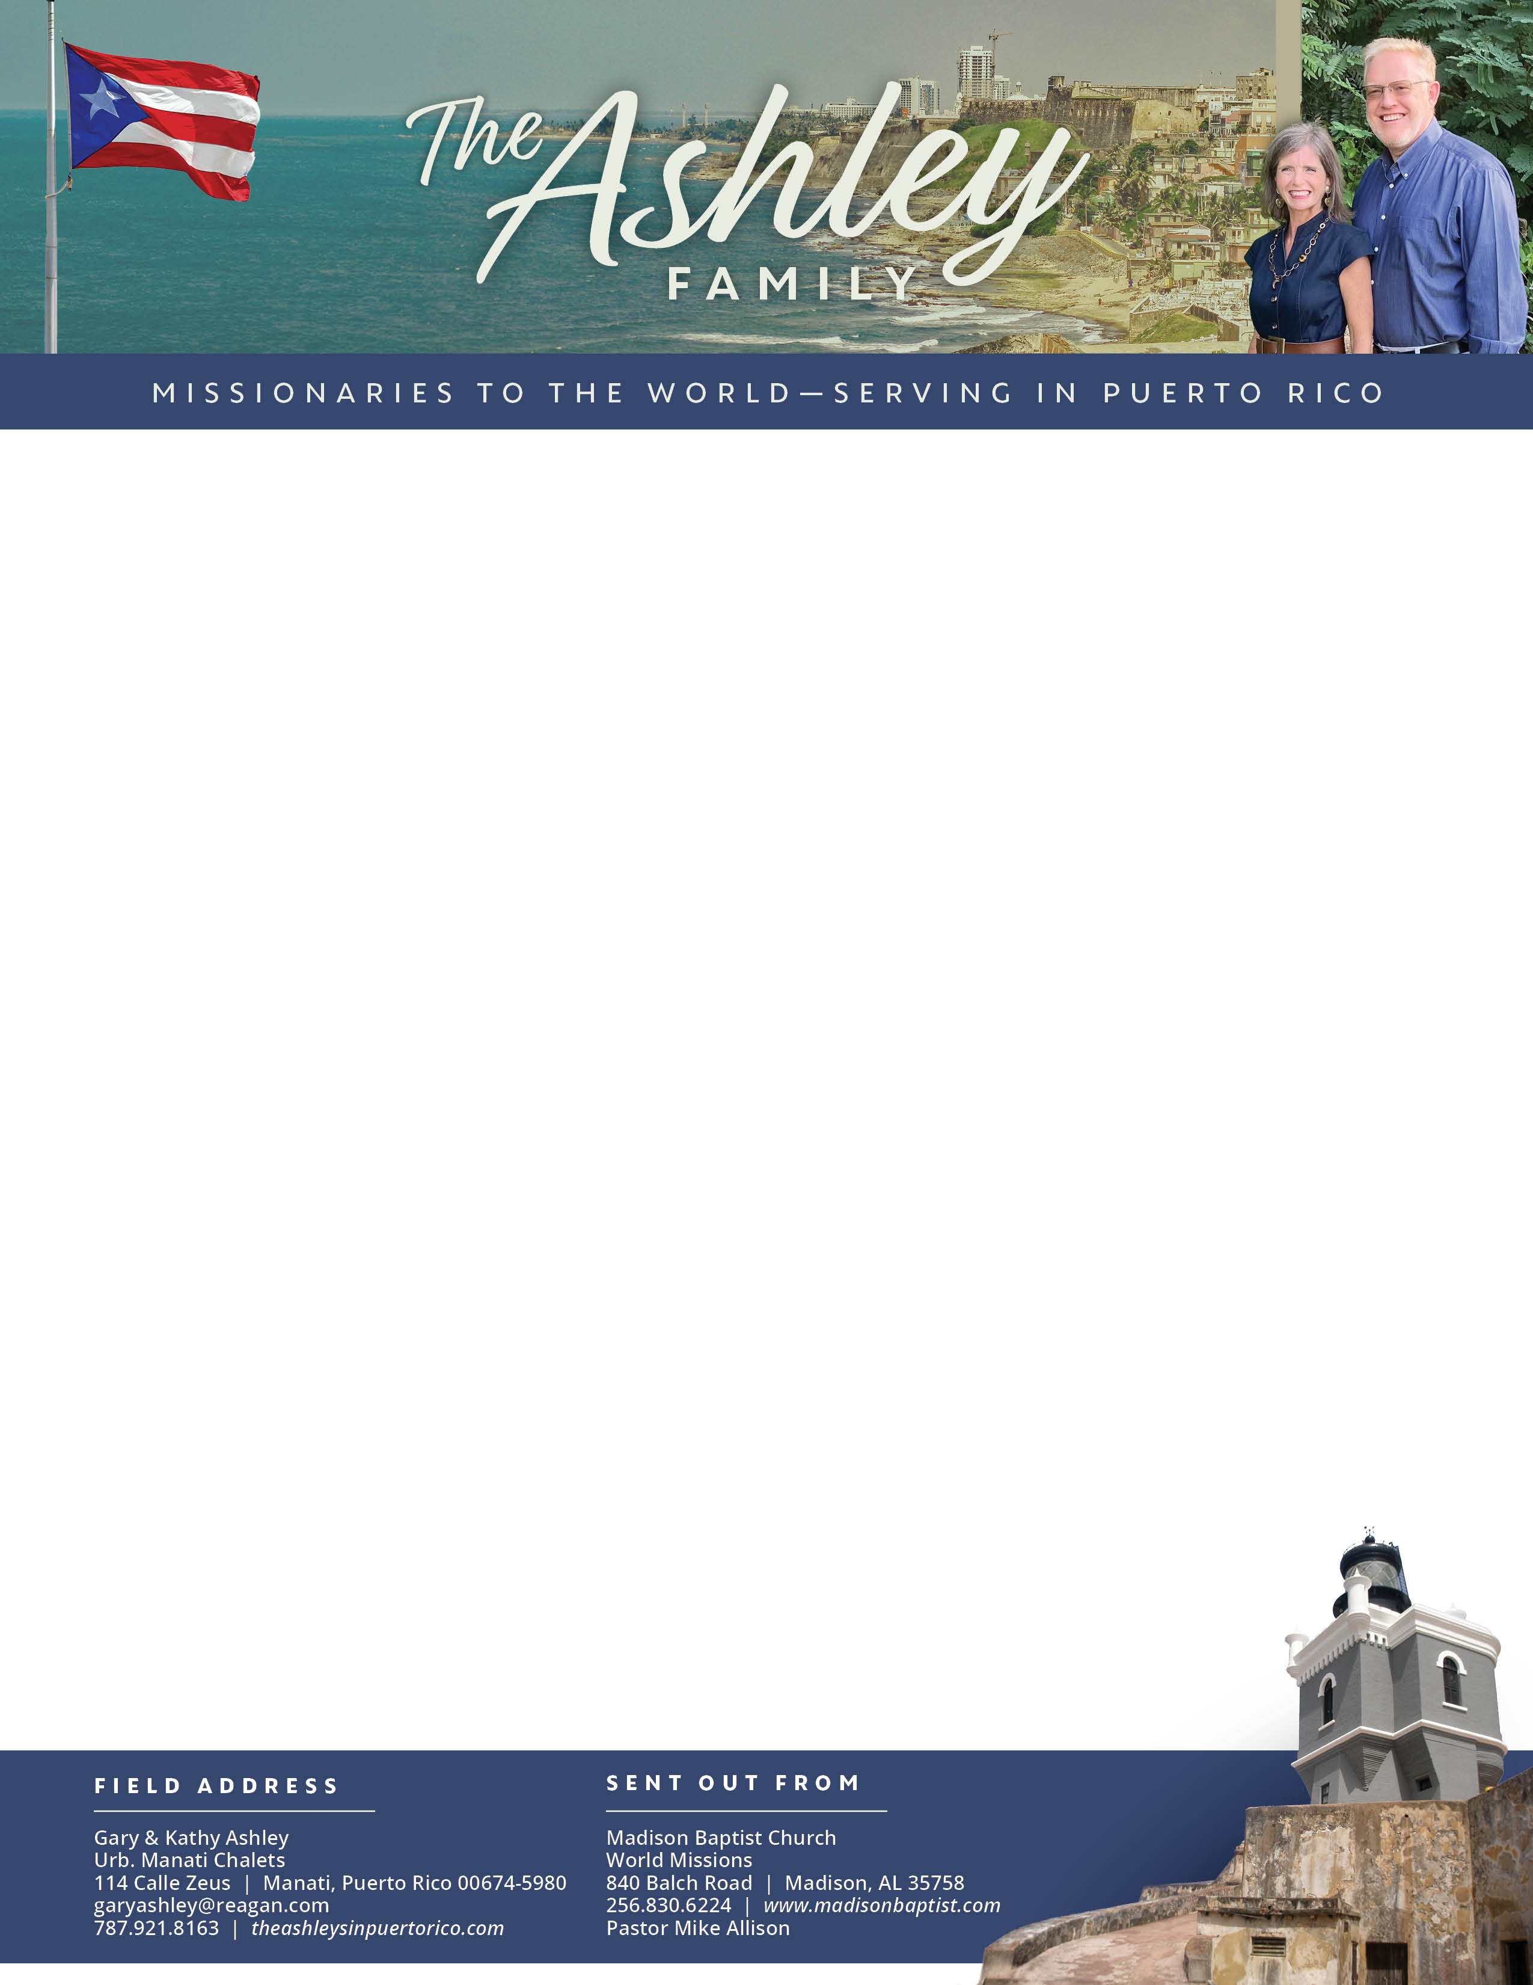

Gary Ashley

*Alaba al Señor*,

(Praise the Lord)

Dear Praying Friends, November / December 2023

**Micah 4:1 “But in the last days it shall come to pass that the mountain of the house of the LORD shall be established in the top of the mountains, and it shall be exalted above the hills; and people shall flow unto it.”** There is no denying that we are in the last days. God sent His Son, the Trinity meets with humans in Jesus, and He is above all other mountains and places to meet God; and the nations shall flow unto Him, Jesus. The three kings (the wisemen) brought their gifts to the new king as the first sign of the nations flowing unto the highest mountain of God, the fullest revelation of God. It is not that we or they could have advanced His glory – He is all-glorious – but that His glory will be manifest in the world/cosmos such that God’s mountain, Jesus, is exalted above other hills or mountains.

These months of November and December have been filled with passing out tracts in new subdivisions, giving out tracts in Walmart, and even giving one to the internet repairman on the street, Charlie. Praise the LORD Charlie came to church to visit us! We have also visited with neighbors, and Kathy was able to have a Girls’ Club in which all were able to attend! They had a terrific time. We pray that as the Gospel is given, it goes deep into each heart and changes each life.

This past week the church voted to give an extra-large love offering to our missionaries for Christmas! How wonderful it is to be a blessing to Luis Quilarque and family as well as Klixon Castillo and family while working for the Lord in Venezuela. The Lord has blessed us, and we pass it on.

My recovery from retina-detachment surgery and laser treatments has gone well; most of my eyesight was restored. My finger surgeries have now concluded and I am in a few weeks of physical therapy. Praise the Lord, it looks as if the finger will return to full capacity!

We look forward to the New Year with new opportunities to serve Him!