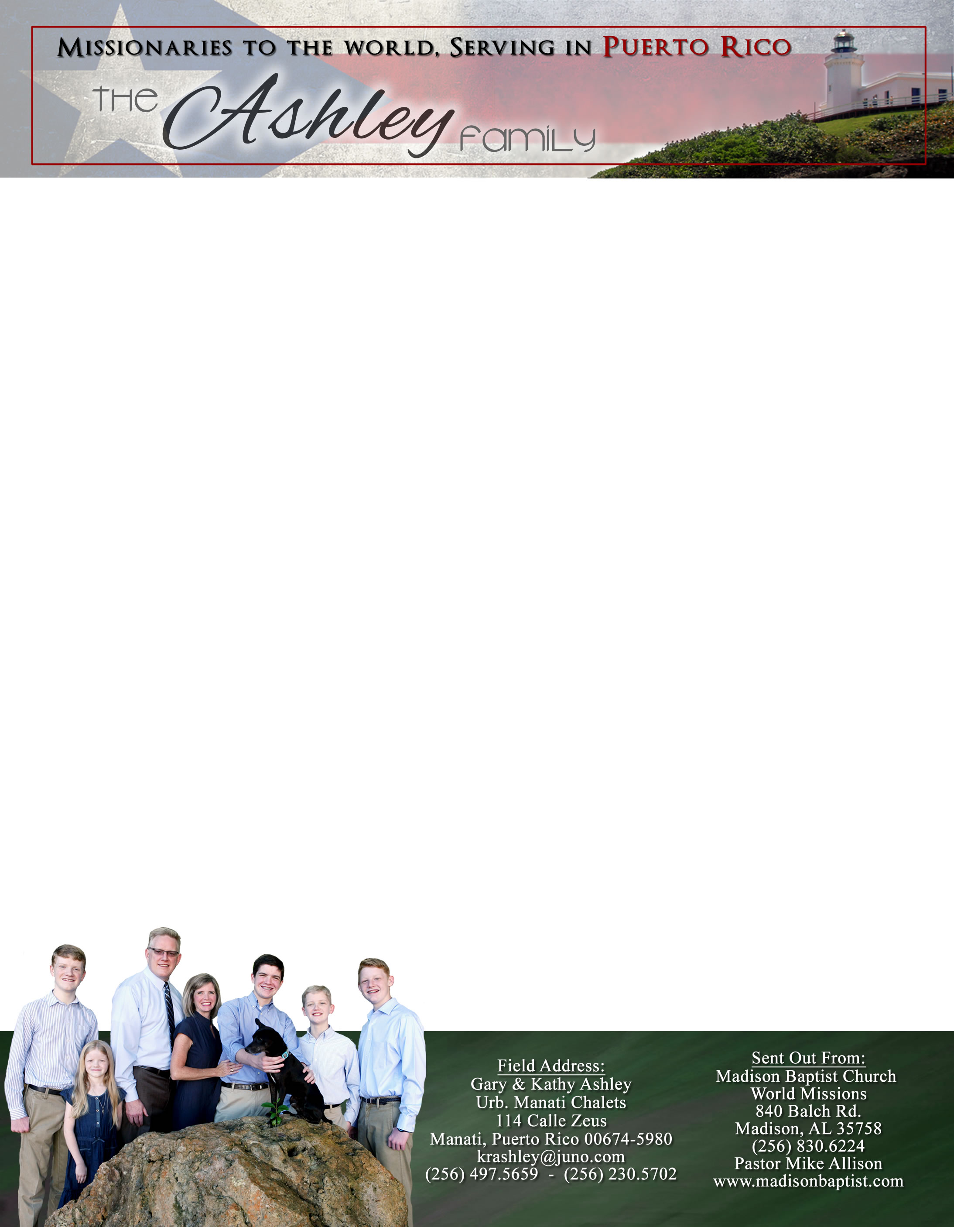

*Alaba al Señor*,

(Praise the Lord)

Gary Ashley

Dear Praying Friends, July / August 2023

**I Timothy 1:12 “And I thank Christ Jesus our Lord, who hath enabled me, for that he counted me faithful, putting me into the ministry.”**

June 30th of this year, it has been twenty-five years since Kathy and I were married; in July of 1998 we began deputation with our home church’s missions conference and flew to Neiva, Colombia, on a survey trip as missionaries. The flight to Bogota, Colombia, and the car trip down to Neiva was an experience itself with delays and car bombs; it seems that these were just the beginning of stories that we can now tell about our experiences as missionaries. After a year and a half of deputation, we moved to Aguascalientes, Mexico, for language school and worked with Bro. Bill Hart in Jesus Maria, Mexico. In 2000, we moved to Venezuela to help veteran missionary Julio Velasquez in Valencia. Through those six years we saw God do a great work, and He continues to work in the churches that we were a part of there. In 2008, we moved to Puerto Rico; for three years we labored in the mountains of Jayuya, and now since 2013 we have been here in Manati, Puerto Rico. God has been so good to us; we have seen Him work in such great ways. All glory goes to Him!

This summer Kathy had the privilege of speaking to the women in the Ladies’ Jubilee of the Sword of the Lord Conference in North Carolina. She enjoyed her trip and meeting many new ladies; she also was able to be with her family for a few days. God has used the three books that have been printed; we praise the Lord for that great opportunity as well. She and Abigail continue to have Girls’ Club; we have new girls that have moved into the neighborhood and we hope to have them attend as well.

Another praise, after four years of a disfigured pinky finger, I have been able to have the first surgery. This had been put off because of the panic of Covid and health insurance that did not cover it; now I have insurance that will help pay the cost of it and the physical therapy afterwards. We pray that these will be successful and help me regain the use of that finger.

We continue to stay busy passing out tracts and inviting people to church. I have had opportunities to talk with people; they show interest and we pray that they will come to church. God has been so very good to us through these twenty-five years of service. There is no better life than the one He gives us.