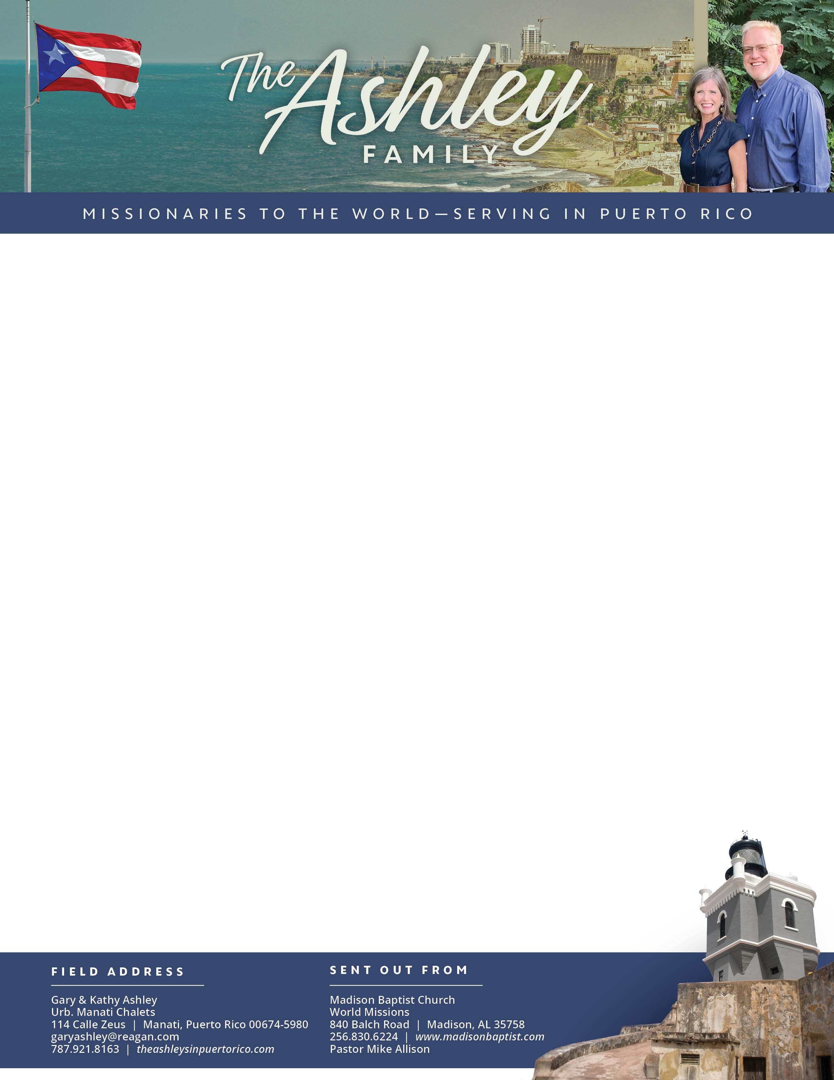

Gary Ashley

*Alaba al Señor*,

(Praise the Lord)

*** New prayer cards are on their way to you!

Dear Praying Friends, March / April 2024

**Jeremiah 21:2 “Enquire, I pray thee of the Lord for us...”** The king of Judah, Zedekiah, asked of God’s prophet Jeremiah to enquire of the LORD for him as he truly wanted to hear from God. Oh! That we would have leaders who would not just say this, but also mean it! We need political, church, and family leaders to enquire of the Lord! They would then be leaders that could help save the people. Paul wrote to Timothy about this in I Timothy 4:16, “Take heed to thyself, and unto the doctrine; continue in them: for in doing this thou shalt both save thyself, and them that hear thee.” Sadly, Zedekiah did reject the word of the Lord; it was not what he wanted to hear. Therefore, the people of Judah went into exile. As a nation we need turn back to God in petitions and follow His Word!

These past two months have been busy for us as we continue to pass out tracts, do Bible studies, and have Girls’ Club. We were so excited to have five new girls at Club; they live in our neighborhood and Abigail with the other Club girls invited them to come. In February, we had ten girls and in March we had nine! They have had the best time together. Charlie did come again, praise the Lord! And on Easter Sunday, Rosemary brought her nephew James and his son CJ. It was such a blessing.

Blessings: Prayer Requests:

1. New people visiting 1. Others to respond to the tracts passed out.

2. Growth of Girls’ Club 2. Mabel and Rosemary have mothers who are feeble.

3. Bible study 3. More ladies would come to Bible study.