

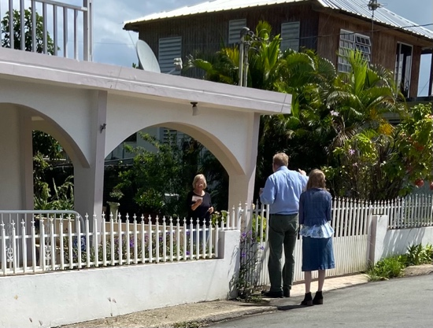

Dear Praying Friends, January / February 2023

**Numbers 23:23 “Surely there is no enchantment against Jacob, neither is there any divination against Israel: according to this time it shall be said of Jacob and of Israel, What hath God wrought!”**

We are studying the book of Numbers in the mid-week service. It has some of the best stories! The false prophet and the evil king were conspiring against God and his people. They were, in a sense, successful because they sent in evil women who caused the men to fall into sin. The women were openly belligerent in their opposition of God. Once all evil and wickedness have finished their work, then believers will look back over life and see the wisdom of God and declare “What God has wrought!” In heaven, all those that have believed in Christ as their Savior will look back over life and say, that which God had wrought was the best and wisest plan. In chapter 25:7-8 Phinehas the son of Eleazar in the moment of the crisis, conflict, and cursing, slew both the Moabites princess and the Israelite man with one strike. Verse 11 says his action turned

away God’s wrath and prefigured the covenant of peace and

atonement. Missions and visitation are much that way. We

press on even if it is illegal, not appreciated by communities or

overlooked in churches; we must depend on what a wise God

has wrought.

As a praise, a new supporter gave to our church finances that

permitted us to buy a new lawn mower for the church. Ours had been stolen two years ago during that break-in. We will add two more solar high output lights to complete our security project relating to that break in. Continue to pray for Ileana and Juana and Stephen’s friend Jose has come a few times.

We have been busy through the beginning of this new year. We continue to go into neighborhoods, knock on gates, handing out tracts at each house. We have accomplished a major section of our city grid! We pray that God will move upon hearts as a result of this planting. We have had a man visiting the past few weeks; we are very excited! Kathy keeps on with Girls’ Club. There are other girls that have been invited; we pray that their parents will allow them to attend. We will look back on this saying, What hath God wrought!

*Alaba al Señor*,

(Praise the Lord)

Gary Ashley