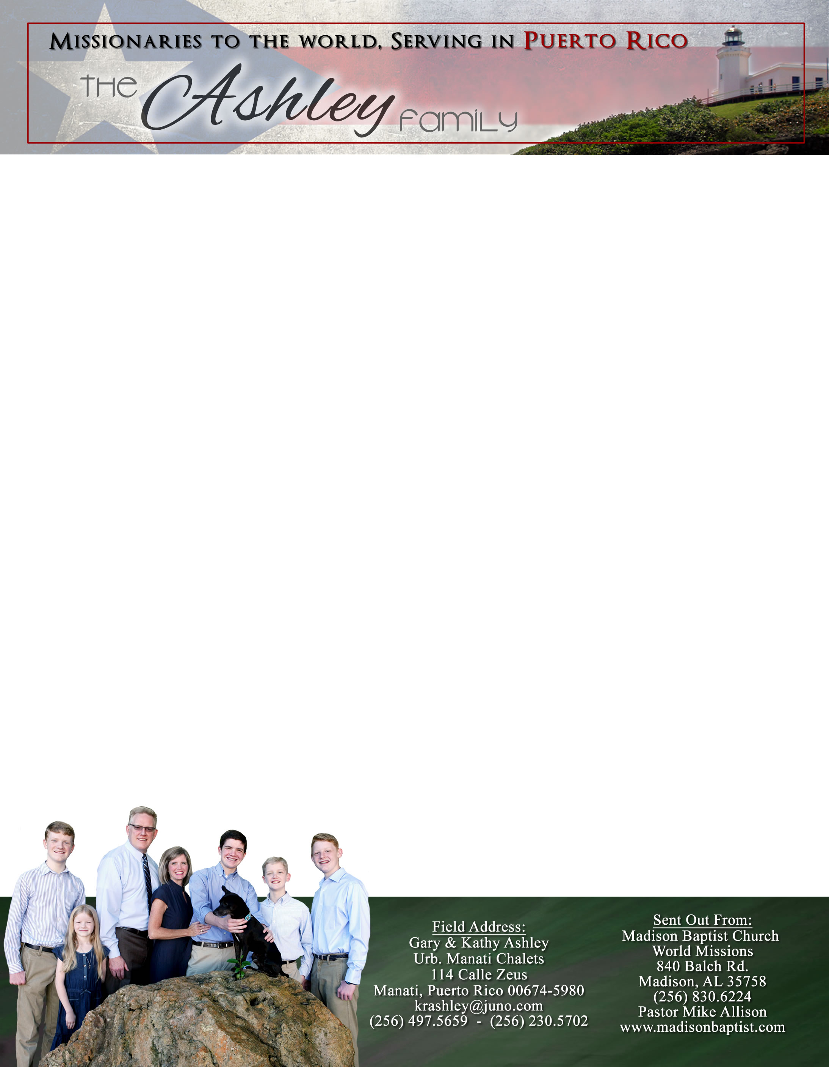 **Andrew & Freddy**

Don’t forget to check out our website – theashleysinpuertorico.com for updates!

We had a surprise this past month; some kitchen cabinets in the upstairs pastor’s apartment fell off the wall. They had been water soaked after the roof blew off during Hurricane Maria in 2017. We had hoped to salvage them since we put on a cement roof. But, alas, they were eaten with termites as well. So, we will be looking to repair that soon. When a national pastor takes over, they will need good kitchen cabinets.

We have also been able to make some new church tracts! They look amazing! A lady in Klixon Castillo’s church in Venezuela designed them for us. We are excited to be passing these out!

Praise the Lord for the work that continues to be done at the church building. We will be putting in a cistern and pump as well as putting in order the legal paperwork. Praise the Lord for the growth in the Girls’ Club! They continue to be faithful! We have had other answers to prayers as well as Rosemary has found a car. She is working on repairing her mother’s house and is seeking a job as she sets up a life here in Manati. Praise the Lord for the faithfulness of Juana, Abraham, Freddy, and Mabel.

*Alaba al Señor*,

(Praise the Lord)

Gary Ashley

Dear Praying Friends, January / February 2021

**Luke 21:27-28 says, “And then shall they see the Son of man coming in a cloud with power and great glory. And when these things begin to come to pass, then look up, and lift up your heads; for your redemption draweth nigh.”**

In the book of Luke, Christ was admonishing His disciples about the last days. Men’s hearts would fail in fear; the earth would have distress of nations. There would be perplexity on every side. Sound familiar? But, we cannot let our focus get too horizontal. We forget the reality of God and His plan. In moments like these, it is good to lift up our heads! We need to look up not just physically as Psalms 121, but also emotionally, doctrinally, and spiritually so that we remember that God is on the throne. The armies have surrounded us (and we are on an island – ha!) and evil has trapped us; but redemption is coming closer. That reminder encourages us to fight on, to stand faithful, and long even more for Heaven and Christ’s return. It was never the waves of the storm (the horizontal troubles) that made Peter go down (drowning), but it was that he was not looking up at the Lord of the waves.