

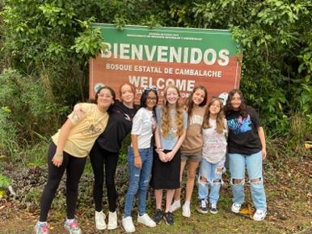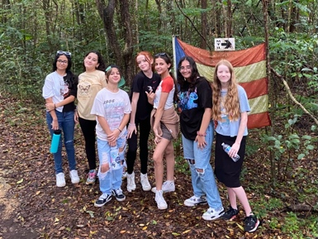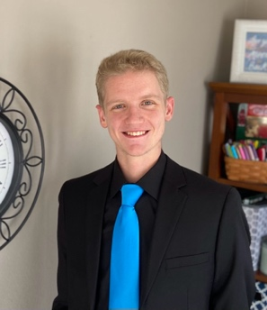

*Alaba al Señor*,

(Praise the Lord)

Gary Ashley

Dear Praying Friends, March / April 2023

**Psalm 127:5 “Happy is the man that hath his quiver full of them: they shall not be ashamed, but shall speak with the enemies in the gate.”**

The arrows that a man has in his quiver are his children. He is a hunter looking for prey and his kids are the arrows used to take down the prey. We take down the prey mostly through the conversion of men. This father may not sit in the gates of power in civil government of the

city, but he prays that his children will. Stephen, my youngest son, is about to

enter Heartland Baptist Bible College to study to be a missionary. We are

excited for him and pray that God will use him far more than he ever used us

to manifest His glory among the nations and in the gates of judgment and

power. Pray that the Lord settles him in and provides a job there as well.

We continue to weekly pass out tracts working our way through the neighborhoods and streets of Manati. We have reached a mark of 1,500 flyers and have printed another set of 2,000 to carry on. We have spoken to them and they have received the tracts. Even if no one is home we have left these tracts on the gate. We pray that God will use these conversations and cards with the printed Gospel to work in people’s hearts and that we can see fruit for His glory.

As a prayer request, this coming month of May I have an appointment scheduled with a gastroenterologist to find out what is wrong with my stomach and digestion. I hope to find some relief; I have completely altered my diet yet the problem still persists. Lord willing, we can finally find some answers.

During Easter week, the girls met again for Girls’ Club. They had a hiking expedition in one of the state parks here in Puerto Rico. After the hike, they ate and Kathy read the story of the Crucifixion and the Resurrection from the Scripture. With all of the misconceptions of Easter, it is wonderful to share the glorious Gospel and to plant the seeds of truth in the hearts of these young girls. Our prayer is that one day these seeds will grow and reach not just them but also their families.