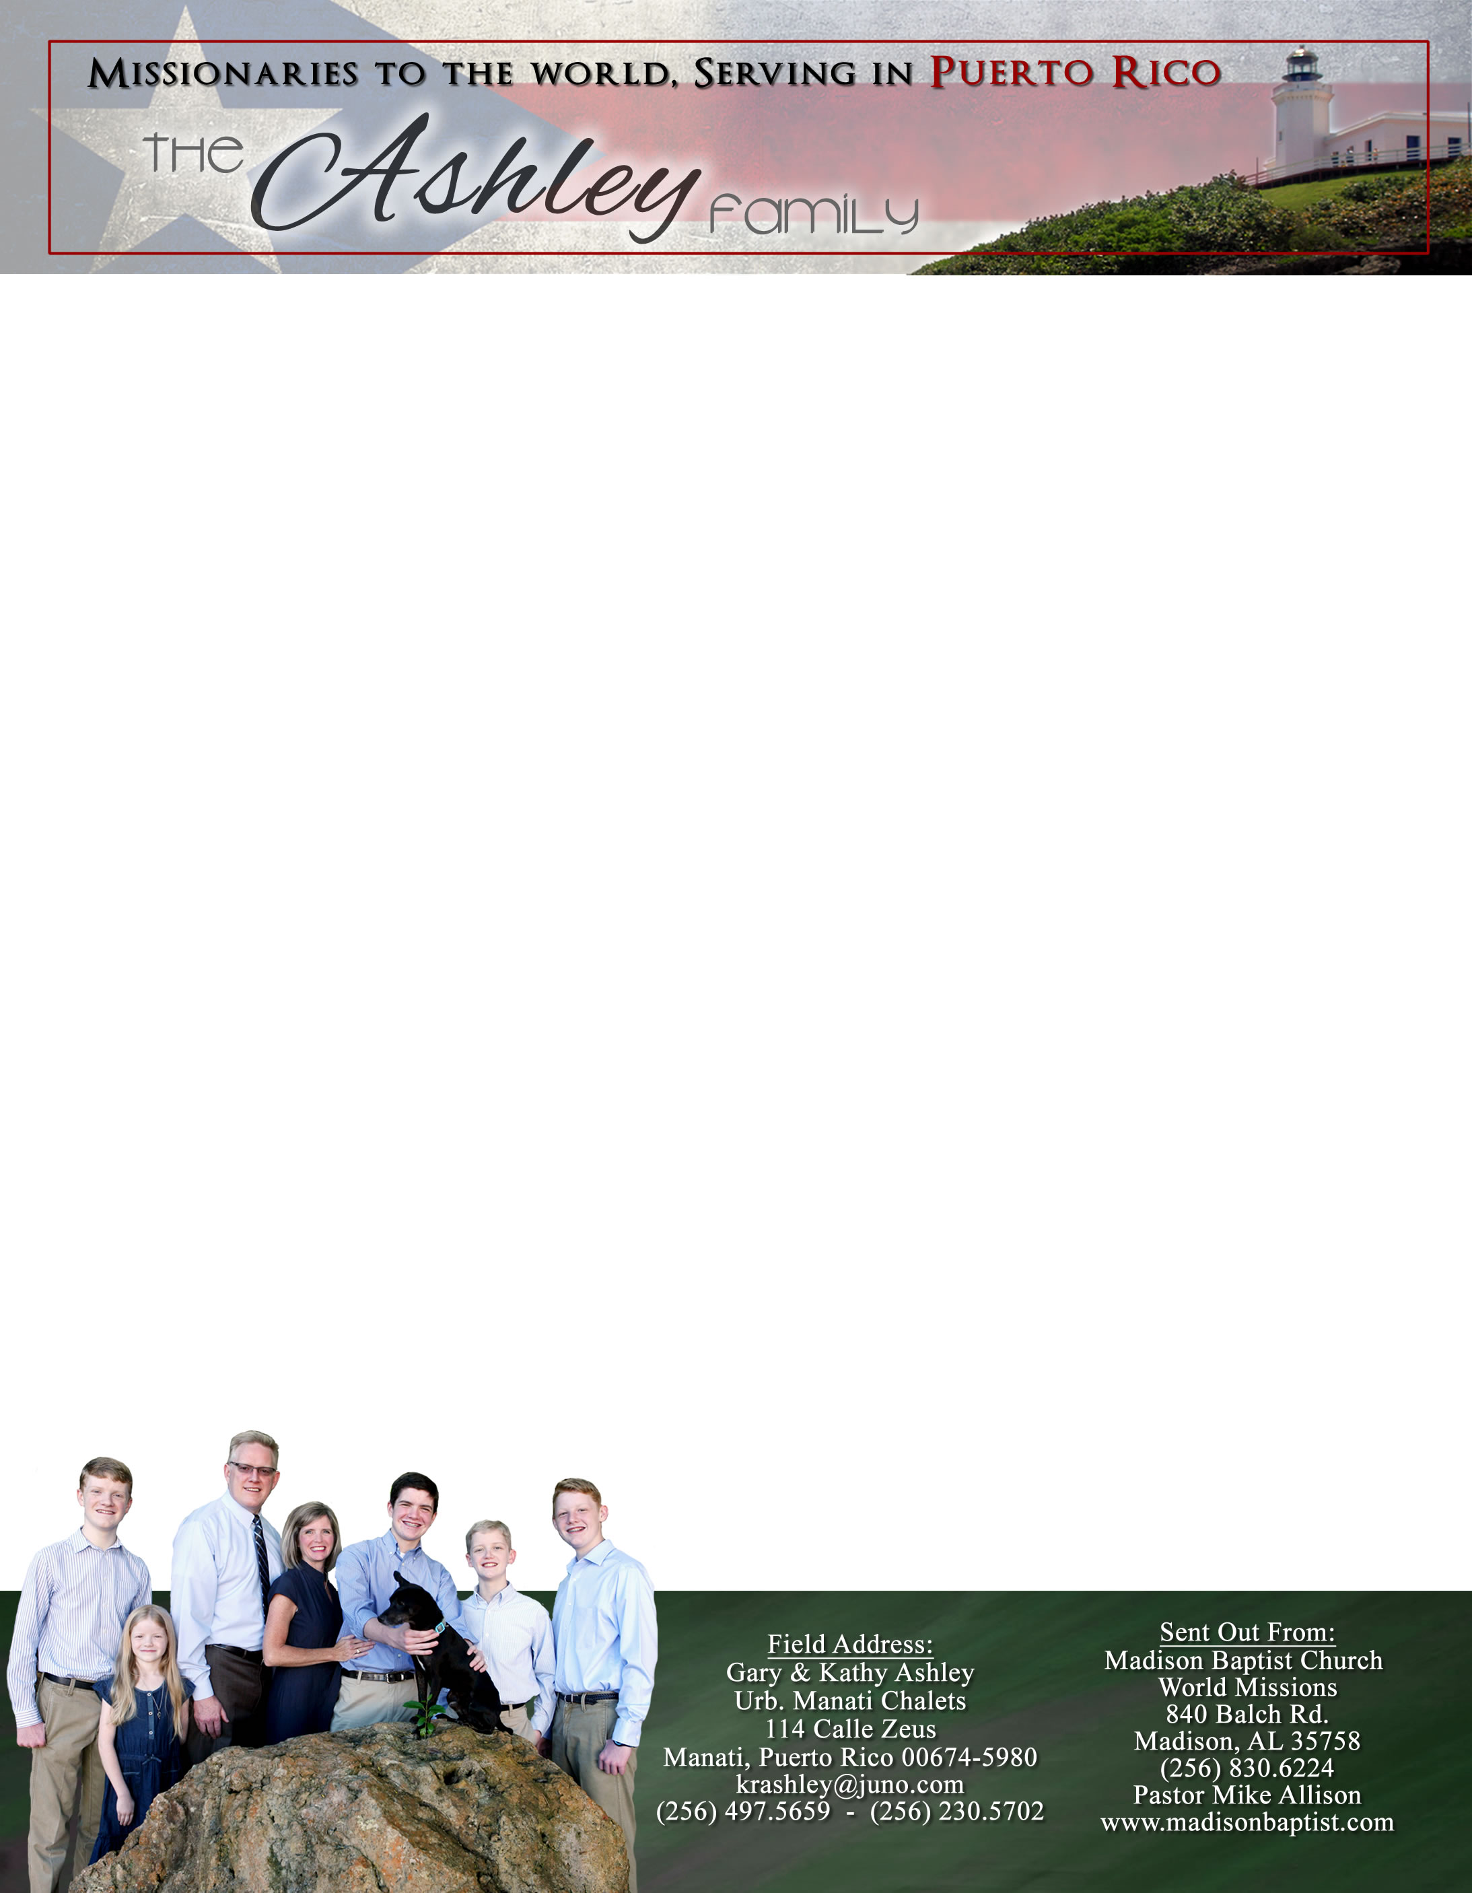 **Andrew & Freddy**

Dear Praying Friends, January / February 2020

**Revelation 21:3 says, “And I heard a great voice out of heaven saying, “Behold the tabernacle of God is with men, and he will dwell with them, and they shall be his people, and God himself shall be with them, and be their God.”**

We all wish to be associated with people who are like us, who affirm us, and who accept us. One day we will go to be with Jesus. He has and will for all eternity condescend to us, to be with us, to associate with us, and to affirm us as we join Him in praising God for all eternity. Through salvation, we have found our true family and friends because He came down and found us. My people are not Alabamians, Americans, or Puerto Ricans but rather believers in Jesus. My family is suffering in Venezuela and hurting in Puerto Rico, but, thanks to God, one day we will unite in eternal felicity.

Praise the Lord that we are still able to repair things here in Manatí as we add security lights and a new secure door that is both inviting and yet much stronger. We also have Mickey from Mount Calvary Baptist Church, our former church in Jayuya, replacing the breaker box and rewiring the downstairs and finally installing the transfer switch for the generator.

Luis Quilarque in Venezuela is going to turn over one of the churches that he started to a new pastor! He also wants to repair a SUV to use for a bus route but needs about $600 to do this - our church here in PR plans to cover half of this; if you would like to help, contact me or Madison Baptist Church.

**https://www.theashleysinpuertorico.com**

We have recently made a new website that, Lord willing, we will be able to keep updated more easily. The old one had not been updated for about seven years because of our difficulty in managing it. We hope that the new website will be able to keep you updated of our ministry here and will allow you to download prayer letters at your convenience. There is the ability to subscribe, as well, that will send notifications of any updates that are made.

We have also included a recent photo of the family. We took advantage of being together at Christmas to update our family photo. God bless each of you in this New Year.

*Alaba al Señor*,

(Praise the Lord)

Gary Ashley