 **Andrew & Freddy**

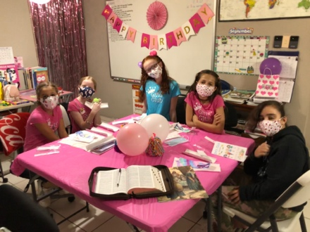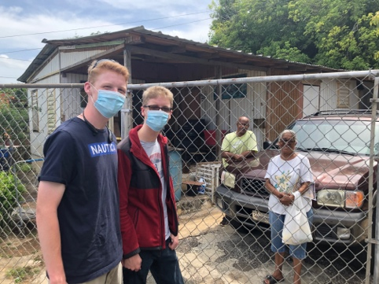

We also are excited as Kathy has been able to start the Girls’ Club again. The girls were ecstatic to be able to get together finally after all these months. Please pray for these girls that through the club we can reach theirs and their families’ hearts with the Gospel.

*Alaba al Señor*,

(Praise the Lord)

Gary Ashley

We have prayed that new people that we have invited would come despite this time. We visited Juana, a dear elderly lady in our church, and her son. Abraham has come twice now and we pray he will continue to come. Juana has been so excited to have her son accompany her. Those who have remained in the church have a great attitude and have been faithful to witness with others. We praise God for the opportunity to serve Him!

Dear Praying Friends, September / October2020

**John 20:19 says, “Then the same day at evening, being the first day of the week when the doors were shut where the disciples were assembled for fear of the Jews, came Jesus and stood in the midst, and saith unto them, Peace be unto you.”**

Jesus had been crucified. The soldiers were paid to say that what occurred was that the disciples had stolen the body of Jesus rather than the resurrection. The disciples were scared because the government and religious leaders had abused their power and had murdered Jesus. Therefore, they hid; but notice, they did not hide separately! As they gathered together on the first day of the week Jesus stood in their midst. Standing there He said, “Peace be unto you.” This peace or well-being is primarily all aspects of salvation, but also their present situation. There should be no fear of creation, leaders, or even sin because the true King said, “Peace.” In the turmoil around us let us not get caught up in the panic and chaos but rather depend upon the true Sovereign of the universe. He is in charge and has done all that we need such that He can honestly say to us ,“Peace.” Even if we are overcome we are still more than conquerors because we manifest His glory and He is working it for good.

We have a Facebook page of our church if you look for **Iglesia Bautista Fundamental de Manati**. We also have a family internet site at **theashleysinpuertorico.com**. Be sure to check us out and bookmark us! We praise Him for Who He is! What a great God we serve!