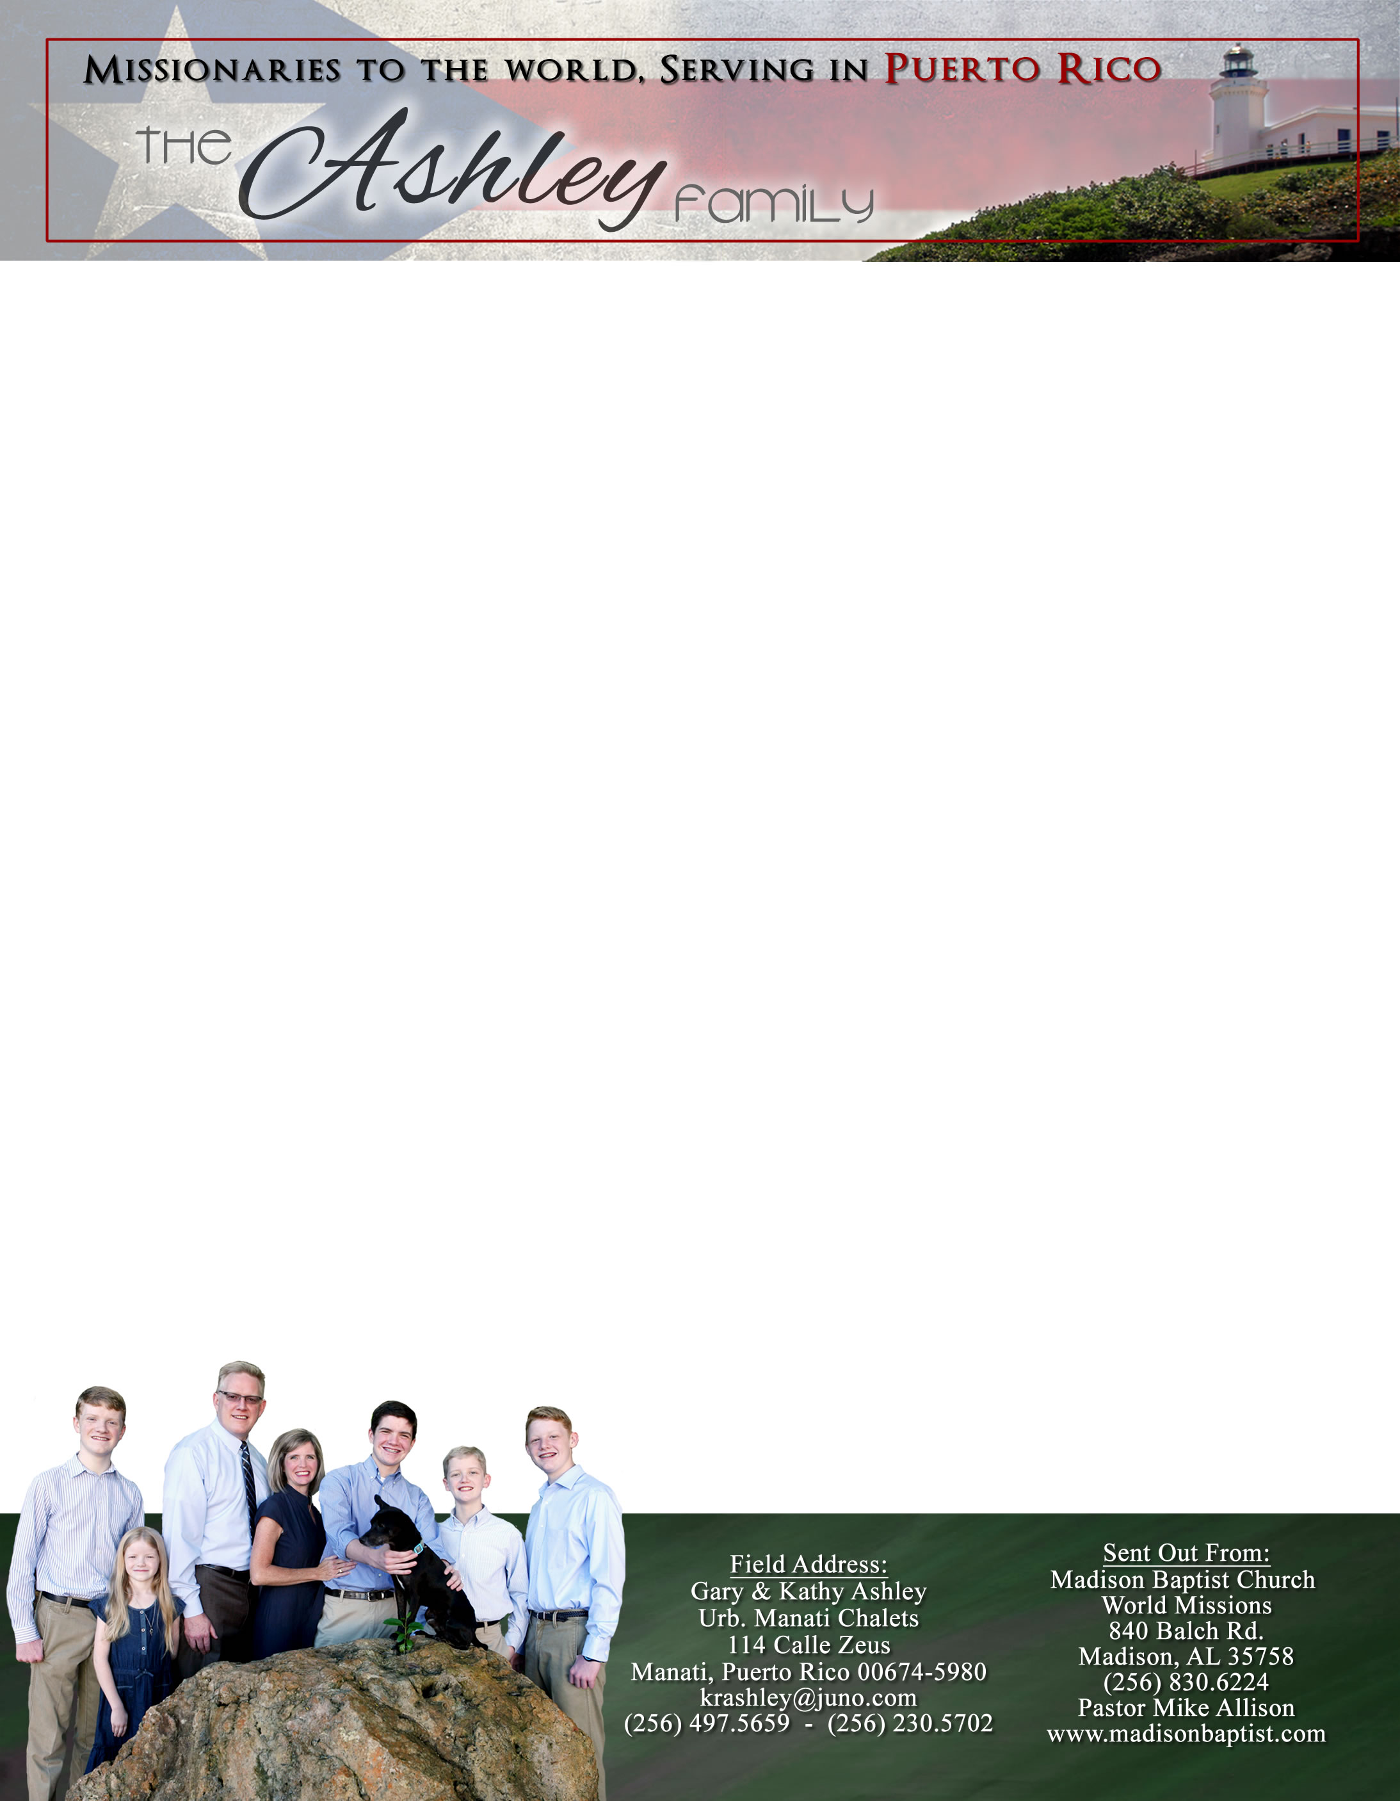 **Andrew & Freddy**

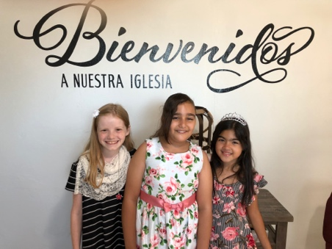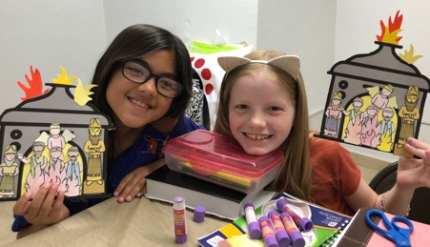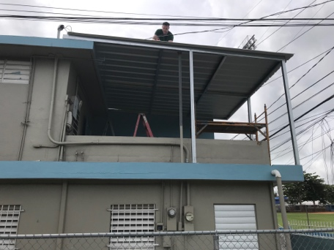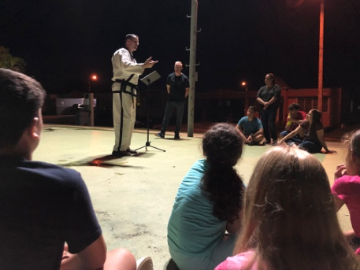

Dear Praying Friends, September / October 2019

**Psalm 119:11, “They word have I hid in mine heart, that I might not sin against thee.”**

The meaning of this verse has been working on me. This verse is commanding us to allow the entire Bible and teaching of the Bible to capture our entire lives and it is not just a call to memorization.

The month of September began the Girls’ Clubs on Friday evenings. We have an average of six girls from the neighborhood that come. Abi has been able to get some of these girls to ride with her to church on Sunday mornings, too, for Sunday School. We often have visitors come one time but do not like the exposition of the Scripture or the lack of a show and never come back, but thankfully these girls still desire to come!

In October, Grace Baptist Church of Wetumpka, Alabama, sent us a thousand dollars and we were able to put a roof on the upstairs patio with the help of Pastor Teate. I was the gopher – “go for this” and “go for that” while he actually got on the roof and helped in the construction! Also, as a master in Taekwan-do, Pastor Teate did an exhibition and self-defense training class and we were able to have twenty-one of our neighbors come! As well, he preached the Gospel to them! Please pray that many good results will come from this as people are saved and new members join the church!

We still need to repair the three bathrooms upstairs with tiles and fixtures, a new breaker box downstairs and a transfer switch for the electrical generator that was provided for us, a new door for the entrance that is more secure with a window and a more cosmetically pleasing appearance. It is amazing how far the building has come from the state that it was in before the disaster as well as after Maria. God has been so very good to us! We praise Him for all that He has provided and done in Manati.

*Alaba al Señor*,

(Praise the Lord)

Gary Ashley