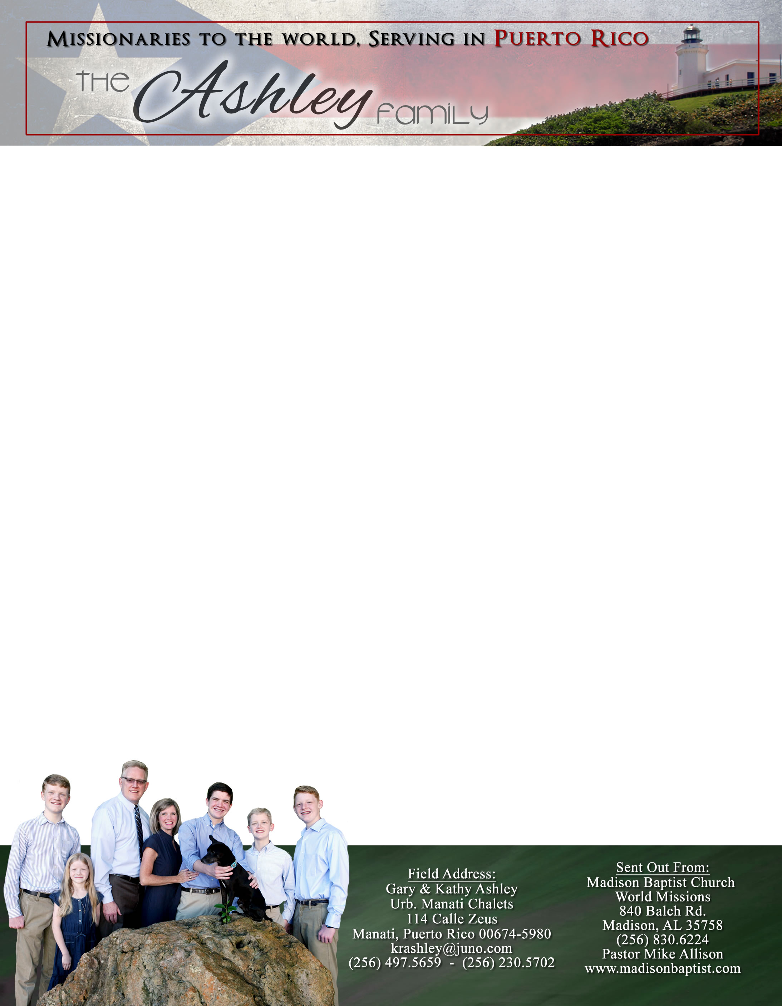 **Andrew & Freddy**

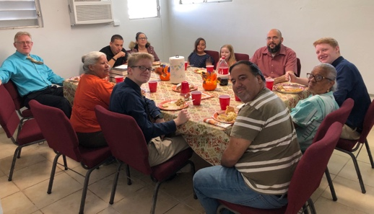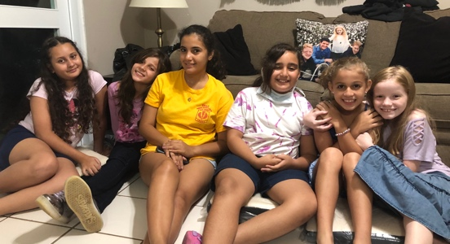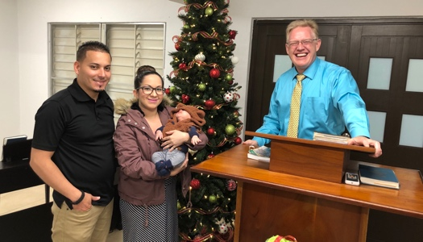

*Alaba al Señor*,

(Praise the Lord)

Gary Ashley

Dear Praying Friends, November / December 2019

**John 1:14 says, “And the Word was made flesh and dwelt among us, (and we beheld His glory, the glory as of the only begotten of the Father,) full of grace and truth.”**

In this Christmas season we celebrate the incarnation of the Son, Jesus. This incarnation reveals to us the Father, demonstrates the compassion of Jesus, makes Jesus’ life the ultimate example, and illustrates how Jesus fulfilled all prophies including His death on the cross.

We praise the Lord during this season for all that God has enabled us to do. With the addition of the roof on the upstairs patio, we have no more leaking in the auditorium! We have petitioned the city’s electric company to fix the electric pole that is leaning strongly on our privacy wall that will eventually knock it down, as well as the wires that are touching the metal roof. We have been able to put up some more security measures and are looking to buy a new security door. Continue to pray and consider helping us to finish repairing the building: tile in three bathrooms, new roof on the entrance patio, new breaker box in the auditorium, and a transfer switch for the generator.

More importantly, the church is advancing. Praise the Lord that Marla and Juan Carlos had their baby, Daniel Adrian, and all are healthy and attending church regularly. They came forward to dedicate their lives to train him in the nurture and admonition of the Lord. We continue to have Girls’ Club on Fridays that reaches out into the community and has brought many girls to church, as well.

We are especially grateful this year that our pastor was able to visit us in this season along with our two oldest sons Andrew and Caleb. They were able to get off work to visit us as well. For Kathy and I, that is one of our greatest joys. Merry Christmas to each of you and the Lord bless you in the coming year as you seek to serve Him more faithfully until He comes.